The Honorable Matthew Cartwright
U.S. House of Representatives 1034 Longworth Office Building Washington, D.C., 20515
The Honorable Gregory Murphy
U.S. House of Representatives
313 Cannon House Office Building Washington, D.C., 20515

March 30, 2021 Dear Representative Cartwright and Representative Murphy,
On behalf of the undersigned, which represents the interests and concerns of well over one million members of the Uniformed Services, their family members, retirees and survivors, we are pleased to offer our support for the H.R. 2192, the Camp Lejeune Justice Act of 2021.

While the Janey Ensminger Act authorized medical care for military and family members who lived at Camp Lejeune and developed conditions tied to the base’s water contamination, there are still barriers in place that prevent the victims of Camp Lejeune’s contamination from achieving judicial relief in North Carolina.

In response to the 2014 Supreme Court decision in the CTS Corp v. Waldburger¹, which held that the Comprehensive Environmental Response, Compensation and Liability Act (CERCLA) does not preempt North Carolina’s 10-year statute of repose, the North Carolina legislature quickly and unanimously passed an amendment to the state’s statute of repose clarifying the statute’s groundwater contamination exception. As a result, the amendment specifically excludes certain tort claims relating to groundwater contamination by a hazardous substance, such as those eventually discovered at Camp Lejeune, from North Carolina’s 10-year statute of repose.²

The Camp Lejeune Justice Act of 2021 will finally bring relief and justice to the veterans and their families living in North Carolina. It was after these veterans and their families were exposed to hazardous chemicals that the North Carolina legislature set a 10-year span for claims, creating a legal impossibility for these victims. By the time veterans and their families realized they had to seek legal redress for injuries, the time to file for redress had long passed.

It is with great pleasure, therefore, for us to support the H.R.2192, the Camp Lejeune Justice Act of 2021, which provides such a path for judicial relief for the servicemembers, veterans and their families exposed to water contamination at Camp Lejeune. Now is the time for these victims to receive the relief they are due, and, in the words of then-Navy Secretary Spencer who defended the denial of claims, to enable these victims to “take their own course of action.”

On behalf of our membership, we thank you all for your service and advocacy for our nation’s servicemembers and veterans. We look forward to working with you and your staff to advance the Camp Lejeune Justice Act, and provide servicemembers, veterans and their families the justice they deserve.

¹ See CTS Corp. v. Waldburger, 134 S. Ct. 2175 (2014)
² See North Carolina General Statute § 1-52(16)

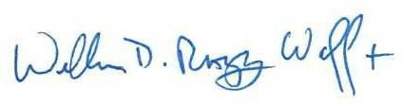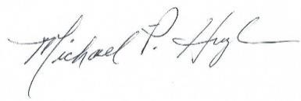

William D. R. Waff, D.Min.,BCC MGEN, USA, Retired
Executive Director
Military Chaplains Association of the United States of America
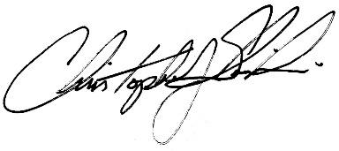
Christopher J. Slawinski National Executive Director Fleet Reserve Association
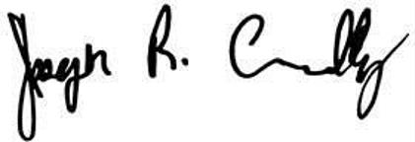

Joseph Chenelly, Executive Director AMVETS

James R Vale
James R. Vale, Esq.
National Service Director, Veterans Benefits & Policy
Blinded Veterans Association
Michael P. Hughes, OSC, USN (ret) National Vice President
Naval Enlisted Reserve Association

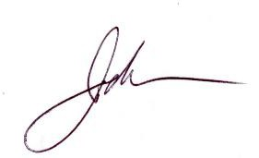
John Rowan
National President/CEO Vietnam Veterans of America

CWO2 Randy Reid, USCG (ret) Executive Director
U.S. Coast Guard Chief Petty Officers Association & Enlisted Association

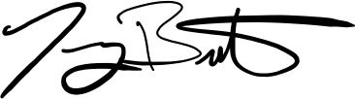
Jeremy Butler
Chief Executive Officer
Iraq and Afghanistan Veterans of America (IAVA)

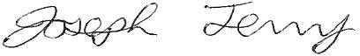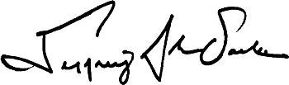

SGM, US Army (Ret) Executive Director
Non Commissioned Officers Association
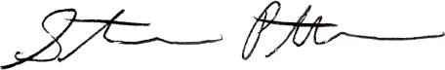

Stephen Patterson
Director of Communications Veterans Education Project
Jeffrey Sacks
JWV National Commander
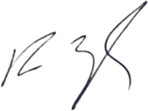
Jewish War Veterans of the USA

Ryan Ziegler Board Member
Special Operations Association of America (SOAA)

