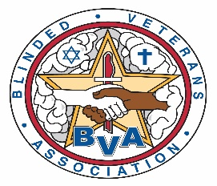
76th Virtual National Convention
August 16-20, 2021
Official Announcement

Dear BVA Member:

Blinded Veterans Association members and their families are invited to attend the annual convention. This letter represents the Official Notice for the 76th Virtual National Convention. The National Convention will be held via a virtual event platform, which will replace the in-person meetings. The notice shall also appear in the BVA Bulletin and on the BVA Website with a full convention agenda.

Registration is now open for the five-day event (Monday – Friday, August 16-20). The registration form may be completed or downloaded online at https://bva.org/, requested via email at bva@bva.org, or by phone at (202) 371-8880. There is NO cost for registration. Registration forms are due by August 9, 2021.

Convention sessions include:
- Official Business Meetings
- Father Carroll Presentation
- Vendor Presentations
- Education Sessions

Voting and Proxy Forms:
- A member wishing to exercise his/her right to vote may do so by registering in advance. If not attending, you can request an official Proxy Form from Brigitte Jones at (202) 371-8880 ext. 330, or by email at bjones@bva.org. Proxy Forms are due by July 26, 2021.

The official National Headquarters Proxy Form and Credentials Form shall be the only forms recognized at the National Convention.

1101 KING STREET, STE. 300 * ALEXANDRIA, VA 22314 * 202-371-8880 (P) * 202-371-8258 (F) * www.bva.org

