The NRTC Community Outreach Guide: How to Host A White Cane Awareness Day Celebration {October 15)
Emily Damm

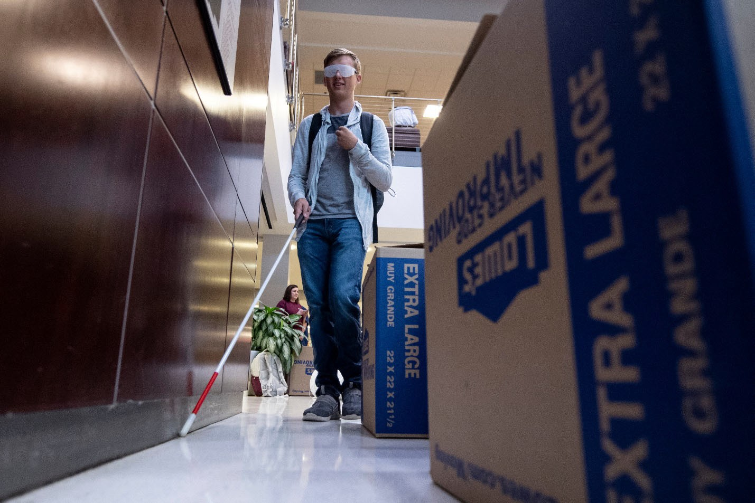

Table of Contents
Letter of Introduction 3
History of White Cane Awareness Day 4
Why Host a White Cane Awareness Day Celebration? 5
General Event Considerations 7
Activity - White Cane Awareness Day City Proclamation 10
Activity - Informational Booth 12
Activity - Adaptive Eating Techniques 13
Activity- Adaptive Cooking Techniques 13
Activity - Simulator Glasses 14
Activity - Free Eye Exams 15
Activity- Braille Interaction 15
Activity - Orientation & Mobility 16
Activity - Object Identification 17
Other Activities 17
Event Promotion - Social Media 18
Event Promotion - Interviews 19
Event Promotions - Invitations 21
T-Shirts 22
Sample Press Release 23

Letter of Introduction

Dear Vocational Rehabilitation Professional,
Thank you for your interest in hosting a community outreach event. This Community Outreach Guide will introduce you to the history of White Cane Awareness Day, provide inspiration for activities, and offer general event tips to support you as you create a successful celebration.
The National Research and Training Center on Blindness and Low Vision (NRTC) provides resources, training, and technical assistance to ensure you are successful in effectively and efficiently serving your consumers. The NRTC, located at Mississippi State University since 1981, is funded by the National Institute on Disability, Independent Living, and Rehabilitation Research (NIDILRR) and serves as a national center of excellence on employment for individuals with blindness or low vision. Our current NIDILRR funding is for a Rehabilitation Research and Training Center on Employment for Individuals with Blindness or Other Visual Impairments (details about these projects are available on our website.
Please consider emailing the NRTC photos, videos, and ideas from your own White Cane Awareness Day celebration. We would very much like to hear how you utilized this guide. Please feel free to contact us with questions, comments, or suggestions.

Sincerely,
The NRTC Team

The contents of this guide were developed under a grant from the U.S. Department of Health and Human Services, NIDILRR grant 90RTEM0007. However, these contents do not necessarily represent the policy of the Department of Health and Human Services and should not indicate endorsement by the Federal Government

History of White Cane Awareness Day

Fast Facts
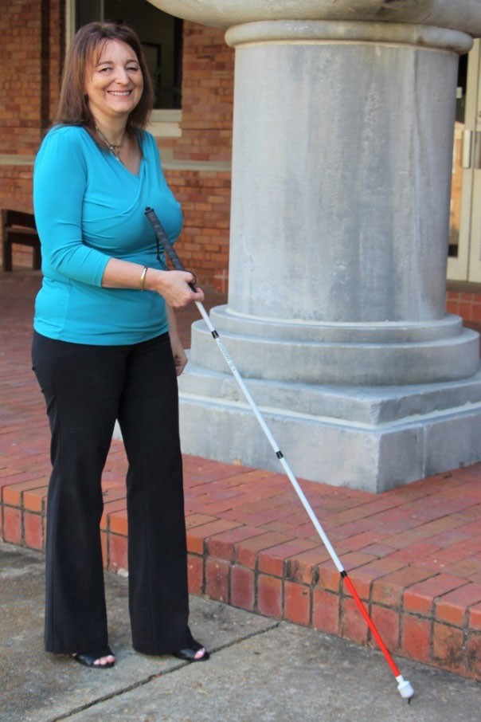
- A white cane is a mobility aid commonly used by persons who are blind or have low vision. It helps individuals navigate their environment with greater independence and confidence. There are various types of canes and cane tips that can be utilized for different goals and terrains.
- On October 6, 1964, Congress passed a joint resolution to authorize President Lyndon B. Johnson to proclaim October 15 of each year as White Cane Safety Day. In his proclamation, President Johnson said,
A white cane in our society has become one of the symbols of a blind person's ability to come and go on his own. Its use has promoted courtesy and special consideration for the blind on our streets and highways. To make our people more fully aware of the meaning of the white cane, and of the need for motorists to exercise special care for the blind persons who carry it, the Congress, by a joint resolution approved October 6, 1964, has authorized the President to proclaim October 15 of each year as White Cane Safety Day.
- Now, the day is more commonly referred to as White Cane Awareness Day. As the National Federation of the Blind (NFB) explains:
To emphasize the shift in focus from safety to independence, and to continue to use the white cane as a symbol, [people] have chosen to refer to this day as White Cane Awareness Day.

Additional Information about History of White Cane Awareness Day
  - National Federation of the Blind
  - Perkins School for the Blind
  - VisionAware
  - Lions Club

Why Host a White Cane Awareness Day Celebration?

Educate the public about white cane safety laws.
Each state has its own white cane law, which can vary slightly. So, consider reviewing the American Council of the Blind's state law list for white canes and dog guides. For creative ways to educate the public about state laws, consider these examples:
  - The City of Springfield, Missouri, created "SGF Yields," an educational and awareness campaign with print pieces, infographics, and videos for download and distribution. You can download these resources on their website.
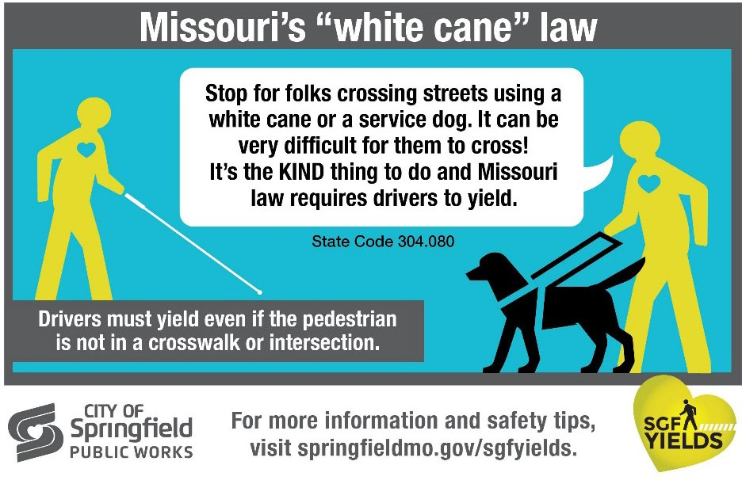

  - The Texas Department of Transportation hosted a "Pedestrian Safety" campaign with video, TV, radio, and print materials in English and Spanish. You can download these resources on their website.
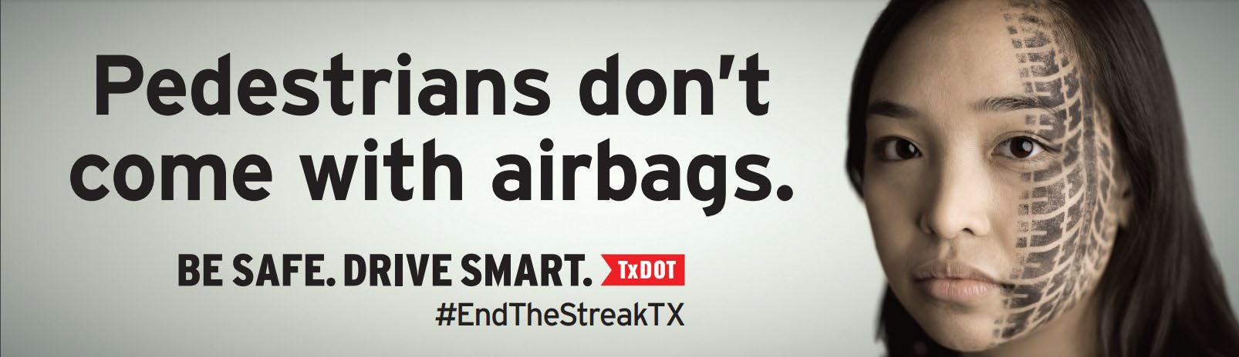

Engage with the public and media about the field of blindness and low vision.
Community outreach is crucial in educating the public about vision loss and addressing negative stereotypes and attitudes about blindness. Take the opportunity to emphasize the value and productive capacities of persons with blindness or vision loss in the community.

Emphasize the importance of learning adaptive skills and other training safely with professionals.
Informing the public about the various services available to individuals experiencing a change in their vision may motivate individuals in need to seek them out. Particular emphasis can be placed on services that assist with job retention, orientation and mobility, and independent living.

Build and create partnerships with other community organizations and leaders.
When similar organizations come together, the public can learn about a variety of related services. Furthermore, established partnerships can increase funding and media attention for an event to reach even more people.

General Event Considerations
This guide includes many activities that you could consider incorporating into your White Cane Awareness Day celebration - from a signing ceremony to a large, public event. As you review these activities in the guide, it is vital to keep in mind the following categories: planning, accessibility, partners, volunteers, and budget.

Planning
When planning an event, consider the big picture.
- Why: Determine the goal of the event. Once you know what you are trying to achieve, it will be easier to decide on the activities and tasks needed to meet that goal. The following are possible strategic outreach goals for consideration:
  - Introduce or reinforce the capability of people who are blind or have low vision
  - Create awareness about your organization
  - Increase website traffic
  - Boost enrollments
  - Educate the community (e.g., about eye conditions, services, etc.)
  - Provide a fun event for current stakeholders
  - Enhance your credibility in the community
- What: Possible activity examples are included later in this guide. You can also reach out to other organizations and groups that have held White Cane Awareness Day celebrations in the past for ideas.
- Who: Once you know the event's goal and its activities, consider the intended audience of your event. For example, do you want to reach new individuals or strengthen the bonds of current stakeholders? Along with the intended audience, consider who should be a part of the event's organization internally. Be sure to include community members with blindness or low vision in the planning process. Note that this section later discusses sponsors, partners, and volunteers.
- When: While White Cane Awareness Day is celebrated on October 15, you do not have to host an event that day. Do you want to host several small events for a week or one large event on a weekend?
- Where: Your budget will likely determine this. If planning an event outside, be sure to have a plan in case of rain or inclement weather.
Tip: Review "Planning Accessible Meetings and Events: A Toolkit" by the American Bar Association Commission on Disability Rights to ensure that accessibility is considered throughout the planning process.

Budget
If you have a budget, you will need to prioritize how to spend funds based on event size, attendance, and overall goal. Potential items for purchase or rental include:
- Venue space - Confirm American with Disabilities Act compliance with your venue regarding parking, bathrooms, walkways, entrances, and service animals' access. Review the Research & Training Center on Disability in Rural Communities guides for Indoor Events and Outdoor Events.
- Tables and chairs
- Marketing materials
- Decoration
- Refreshments for staff and volunteers
- T-shirts (see t-shirt examples later in the guide)
- Materials for activities
- Trashcans, trash bags
- Sleep shades
If you do not have a budget, you can still reach out to local organizations, churches, groups, and individuals to see if they would provide funds or items to support the event as a partner or a sponsor.

Sponsors and Partners
If you decide to pursue sponsors, you need to consider the following:
- Relationship - Decide on which partners to pursue. Do they make sense for your organization and this event?
- Timing - You will need to make requests early on to ensure that they can consider your request. Some organizations have a limited outreach and advertising budget that they plan annually. So, you will need to reach out as soon as possible. If they say yes, you'll also need the time to deliver on agreements.
Once you have considered an organization's relationship and timing, decide how you will reach out to them. From there, create an appropriate pitch. To do so, consider what they will get from sponsoring the event (e.g., increase in awareness, bump in sales, improved brand image). Then, consider how you could easily discuss this benefit from them. You will need to emphasize how the audience and publicity from your event will benefit them. Consider offering different levels of sponsorship.
- You can request sponsorship in exchange for logo placement on flyers, social media posts, t-shirts, and other products.
- You can also request sponsorship in exchange for a booth or an opportunity to speak during the event.
- You could request they donate time as volunteers.
- You could request they donate a raffle prize or even post a flyer in their store.

Recognize that a "no" is okay. Be sure to continue to communicate with them so that they will consider sponsoring a future event. Perhaps send them a thank you for their time. You can even send them information after your event with data and images for their consideration the following year.
You could also consider using a crowdfunding resource like Kickstarter to request support from individuals rather than an organization or business.

Volunteers
If you do need volunteers, consider the ideal number of volunteers and their possible roles throughout the event.
- Ideal number - Be thoughtful in deciding the needs of your event and how other individuals can assist. You do not want to have so many volunteers that they have nothing to do because then they will say no to helping in future events when you do have a need.
- Roles - Do you need trained professionals to volunteer? Do you simply need bodies to provide directions to restroom locations and event activities? Note that regardless of the volunteer's role, you will want to ensure they receive basic training on the event agenda, venue space (e.g., bathroom locations), event goal, and how to interact with and help people with disabilities. As volunteers, they will represent your organization and event. So, you want to be sure that they are knowledgeable and kind. Consider how you will provide this basic training to volunteers.
Many local service organizations are searching for volunteer opportunities and could likely assist in your event. For example, Kiwanis, Lions, Rotary, Civitan, social clubs, Boy Scouts, Girl Scouts, and more. Lions International has an objective to "prevent avoidable blindness and improve quality of life for people who are blind and visually impaired ." So, their members would make great volunteers for a White Cane Awareness Day celebration.
Tip: Be sure to send personalized invitations. Once you have confirmed volunteers, follow up with them regularly.

Activity - White Cane Awareness Day City Proclamation

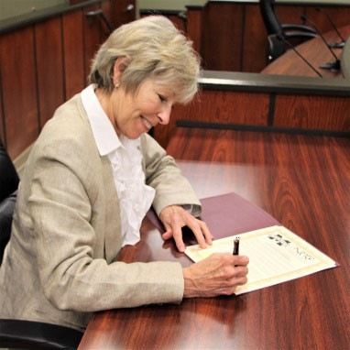
What is it?
Mayors typically issue city proclamations for important community events. A city proclamation provides an opportunity to meet with your Mayor and other city officials and reach a broad audience via press coverage.

How to organize?
Two months prior
Learn about how to pursue a city proclamation in your area and write a draft. Some offices have specific templates, rules, or guidelines associated
with proclamations. So be sure to visit your local city's website before proceeding with writing a draft. For sample city proclamations, visit NFB's website.
Once you have a draft, visit your city's website to see if there are formal steps to request a proclamation. If there are communication guidelines, follow them. Otherwise, reach out to your Mayor's office with your request via phone or email. During this communication, include:
- Information about your organization
- Information about the importance of proclamation
- Information about the language of the proclamation
- Information about your expectations of the signing ceremony (stand-alone event, an event with speeches, incorporated into other activities, etc.)
A signing ceremony could last five minutes for just a photo and signature or could become a larger event with speeches from local officials, the general public, and your organization. These expectations should be made clear to the local office before finalizing the date and time.
Once a date and proclamation are agreed upon, ask the city's office if the press and the public could attend. If so, communicate with key stakeholders about the proclamation.
One month prior
Disseminate invitations and a press release (see example in this guide) to key stakeholders. Consider the following:
- Photos - Will you take pictures? Do you have a photographer attending? Do you need to have a photo release form?
- Volunteers - Do you need volunteers to provide rides to the location or human guide upon arrival?

- Location - Is it accessible? How can you ensure attendees can easily find and reach the location? Is it appropriate for the number of people that will gather?
- Agenda - Is your event large enough that an agenda is needed?
- Press - Do you have a statement prepared? Will you accept questions or interviews before the event? During the event?
- Dress - Do you need to provide invited guests guidance on dress code recommendations?
One week prior
Many government officials have an evolving schedule. So, be sure to communicate with your city office staff again about the proclamation as a reminder. During this time, provide an estimate for how many people you expect to attend the proclamation signing. Communicate with volunteers about expectations as needed. Post about the event to social media and communicate again with the media. Be sure to engage with relevant partners on social media.
Day of event
Depending on how many people and members of the press you expect, arrive at the location early to facilitate attendees. If applicable, be sure to follow your agenda for the day. Be sure to promote your event via social media and other dissemination channels.
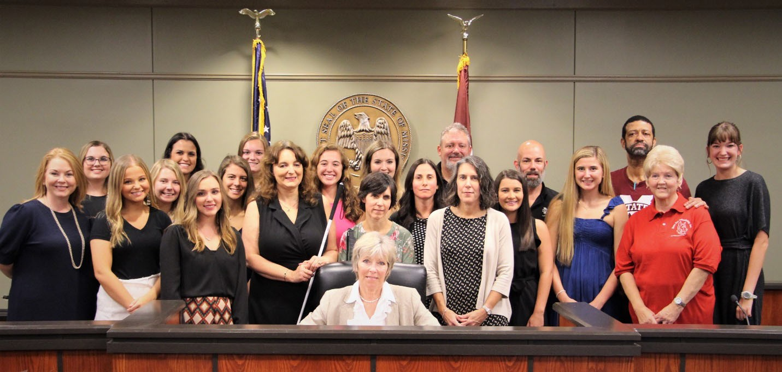
Day after event
Be sure to send personalized thank you letters to all involved in making your proclamation a success. Write an internal guidance document of what went well and ways to improve so that you can have an even better event the next year!

Activity- Informational Booth
Host an informational booth with free materials:
- General information related to blindness and low vision
- Brochures and flyers for your organization
- White cane materials
  - Informational (e.g., 10 Fascinating Facts about the White Cane)
  - Action-oriented (e.g., Free White Cane Application from NFB
- Information about careers in the field of blindness and low vision
  - Association for Education and Rehabilitation of the Blind and Visually Impaired (AER) has flyers about a variety of professions, including Low Vision Therapists, Orientation and Mobility specialists, Teacher of Students with Visual Impairments, Vision Rehabilitation Therapists, which are great options!
Tip: If you host an informational booth along with other activities, place the booth in a central area so attendees can find it to ask questions. It is best for it to be at a location that most attendees will immediately walk by - before any other activities.
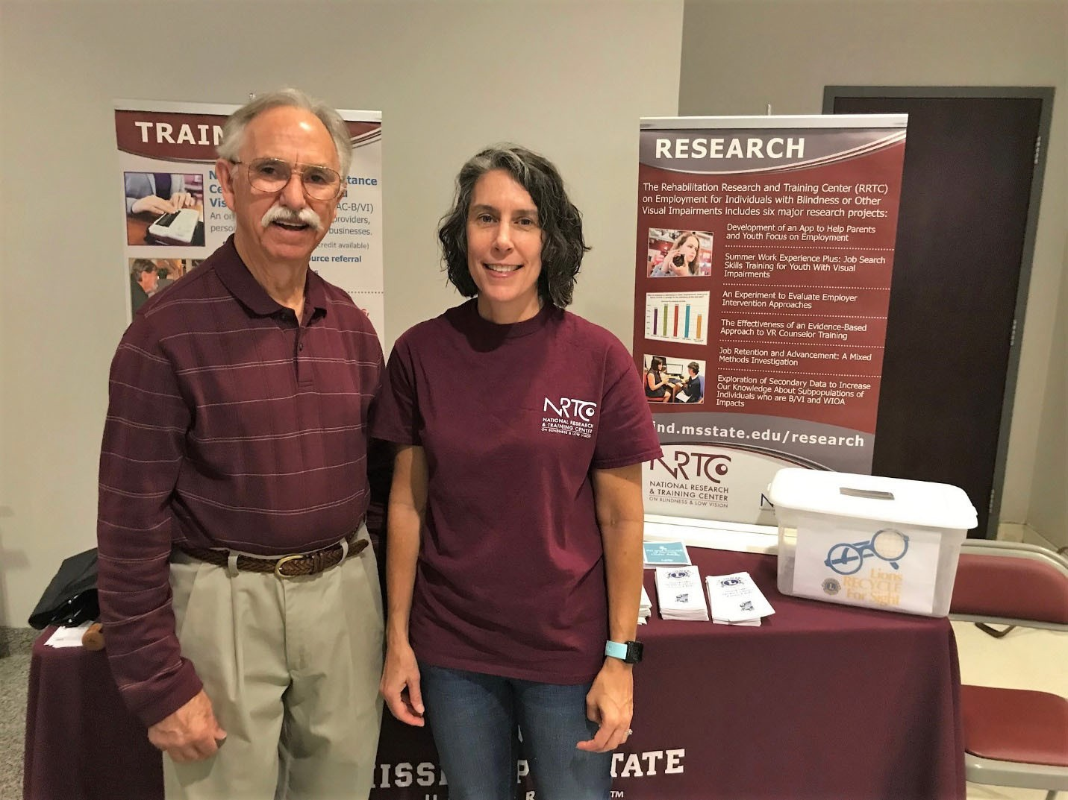

Activity - Adaptive Eating Techniques
After teaching adaptive eating methods, provide the participant with an opportunity to eat something while wearing simulator glasses, a sleep shade, or a bandana over their eyes. Ideas for instruction include:
- Methods to locate plate, silverware, and napkin (e.g., back of the hand with curled fingers)
- Ways to identify the food on the plate (e.g., clock method)
- Benefits of food presentation (e.g., contrast from plates and tablecloth)
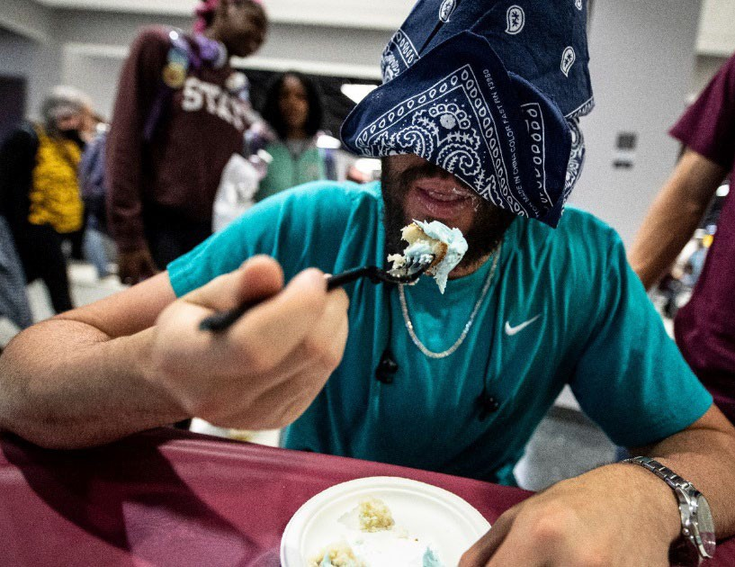
Providing a fun activity like eating a simple food introduces several useful terms and techniques to the participant. The participant can then recall this information when dining with a person who is blind or low vision. Furthermore, it also allows the participant to experience an adaptive skill that helps them overcome something they may have perceived to be challenging!
Tip: Reach out to your local grocery store to ask if they would consider donating a food option for the event.

Activity - Adaptive Cooking Techniques

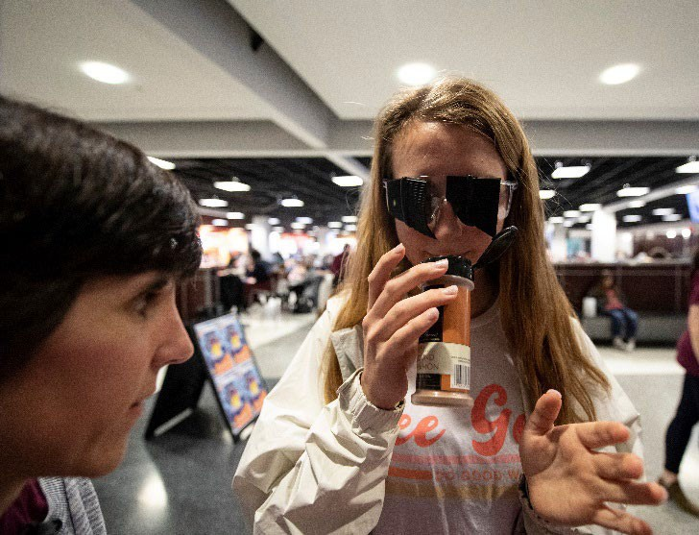
Spice Identification
Ask if the participant can identify spices just by the smell. Can they recognize cinnamon? Rosemary? Oregano?
Peppermint? Turmeric? This provides the participant a chance to rely on a new sense for something they may have previously believed could only be done by sight. This activity also offers an opportunity to discuss and dispel the myth that individuals with blindness develop a sixth sense.

Pouring
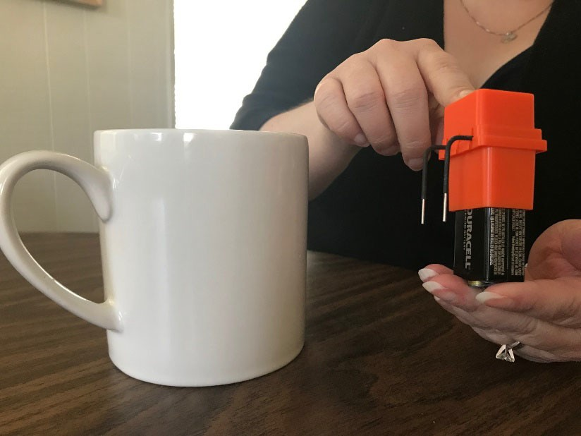
Demonstrate pouring liquid from a pitcher into a mug with the use of a liquid level indicator. Ask the participant to do the same. How did they do? Discuss how something as simple as a liquid level indicator could be used in other situations.
What other devices are there that help in the kitchen?
Benefits: Allows participants the opportunity to learn easy adaptations, build confidence in their own abilities, and perhaps
bust myths related to blindness (e.g., "Blind people have a sixth sense!")
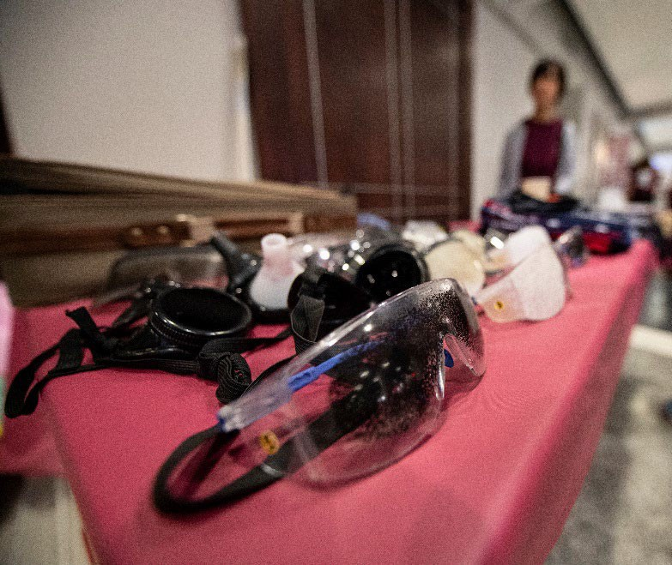
Activity - Simulator Glasses Encourage participants to try on various simulator glasses to experience different eye conditions, such as macular degeneration, cataracts, diabetic retinopathy. Then ask them to complete an activity such as identify certain coins, take notes, or select an item on a menu. Be sure to consider tasks that are manageable and will not frustrate the participant. This activity has several benefits:
- Allows the participant to recognize the spectrum of vision regarding blindness and low vision conditions.
- Provides an opportunity to discuss various eye conditions and possible treatments and managements related to each.
- Demonstrate that tasks can still be completed with modification or adaptations.
If you do not have simulator glasses, consider providing image comparisons. Be cautious about your descriptions of these conditions. You do not want to cause someone to have a negative view of someone who is blind or has low vision. The goal is always to educate - not scare!

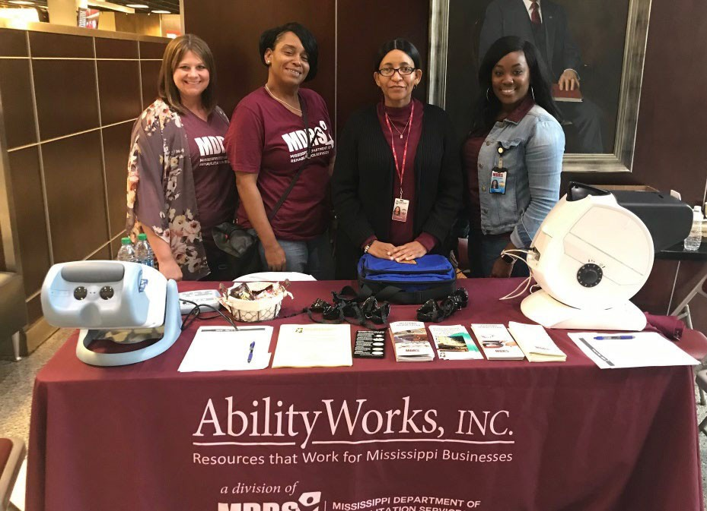
Activity - Free Eye Exams Offer participants a free eye exam, including a check for glaucoma, and discuss the importance of regular eye exams. This community
service provides visibility of your organization and could introduce you to future participants in your program.
Tip: Consider reaching out to a local ophthalmologist or optometrist to see if they would like to donate their time as part of their community outreach. Similarly, Lions
clubs often partner with medical professionals to provide vision screening for youth, students, and adults.

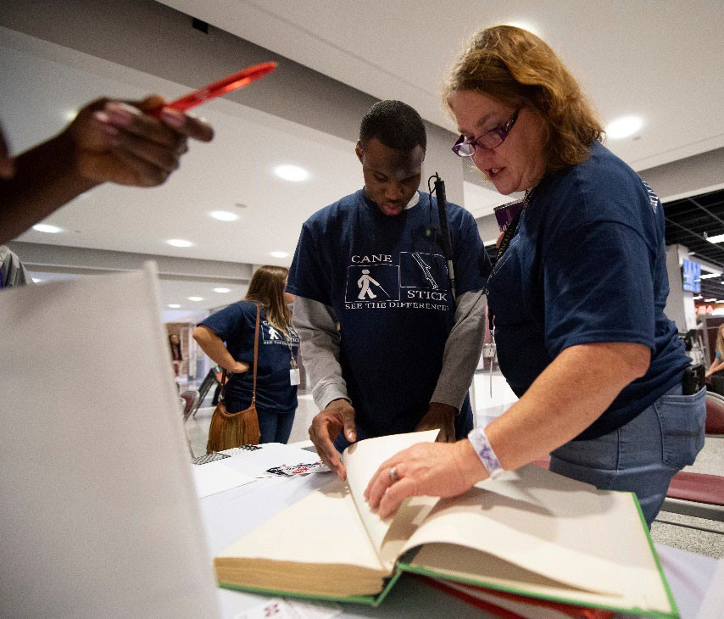
Activity - Braille Interaction Provide various braille books for the participant to view and touch.
Discuss how braille can be used beyond just reading, but in math and music, too! Provide a braille alphabet card to the participant. Braille alphabet cards are an affordable giveaway for events like this. They are fun and can include your organization's contact information. Consider embossing the participant's name to spark their interest (and keep them from throwing it out right away)!

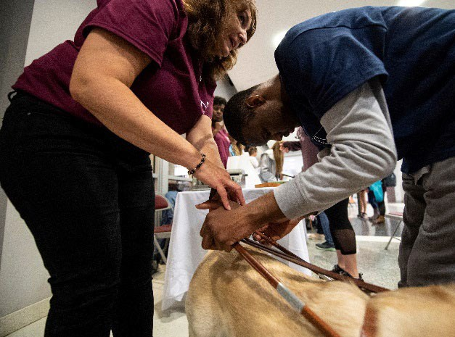
Activity - Orientation & Mobility Discuss and demonstrate various orientation and mobility tools, such as:
- Human guide
- White cane
- Dog guide
While discussing these options, teach the participant the appropriate way to offer help to an individual with blindness or low vision. Be sure to emphasize that some individuals may decline assistance, and that's okay!
After providing an overview of various orientation and mobility tools, teach the participant how to provide human guide properly. For a fun way to demonstrate and teach this technique, create an "obstacle" course. If you decide to do this, consider offering various "levels" to the course:
- Level one - walk the course with the participant and point out things you would say if you were providing a person human guide
- Level two - provide human guide to the participant while they wear simulators or a bandana. Since they are already familiar with this route, you can focus on making sure they are comfortable and confident
- Level three - ask the participant to provide human guide to another participant
Offering various levels allows the participant the chance to gain confidence in the human guide technique. Allow the participant to repeat levels to their comfort - and never pressure them into completing a "higher" level. As they complete the course multiple times, the participant can learn that it becomes easier to navigate a familiar environment.
When setting up this "course," consider incorporating naturally occurring items into the course to allow for a discussion of accessible architecture. For example, the edge of a sidewalk, a low hanging branch, a turn at a water fountain, and other similar environmental cues are great to include in this activity.
Be sure to focus on the educational component of this activity. The obstacle course should not be too challenging to scare the participants or leave them with a negative attitude towards individuals with blindness or low vision.
Depending on the event's goal and audience, you can adapt this activity to include different tools and techniques. For example, the National Federation of the Blind once hosted a Cane Walk event where sighted family members participated in a travel lesson with a white cane. Many other organizations around the country chose to do a similar activity.

Activity - Object Identification
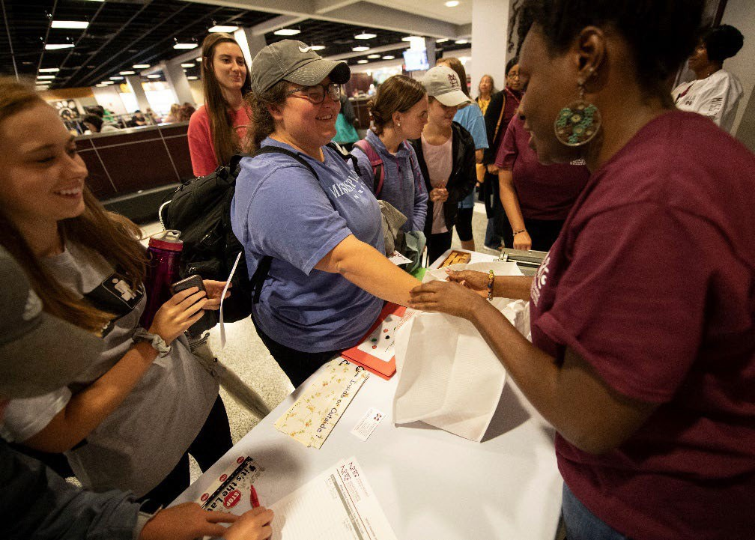
This simple activity involves placing everyday objects into a bag. Ask the participant to reach in and see if they could identify the object without looking.
Ideas for consideration include:
- Gum
- Hairbrush
- Lip gloss
- Phone
- Tissues
- Wallet
- Watch
Similarly, you could place an object on a table and ask them to find it using the clock method.
This fun activity can demonstrate the independence of individuals with blindness and low vision.

Other Activities
- Organize a game of goalball - Be sure to get a participant waiver signed!
- Teach adaptive skills for clothing (folding items, matching socks, etc.)
- Offer a Meet the Blind booth - partner with an NFB or American Council of the Blind (ACB) chapter for this activity
- Host a Twitter Chat with a hashtag
- Organize a parade or walk (could be virtual)
- Demonstrate the use of talking items or other assistive technologies (e.g., braille notetaking device, JAWS/NVDA, etc.)

Event Promotion - Social Media
If you have an active social media account for your organization, create social media graphics to promote your event. These can easily be shared by staff and stakeholders.
The following are the current social media graphic dimensions:
- Facebook posts and timeline photos: 1200 X 630 pixels
- Twitter in-stream photos: 1600 X 1900 pixels
Tip: There are ways to create accessible social media posts through tools such as alternative text. For more information, read this article about inclusive design for social media.

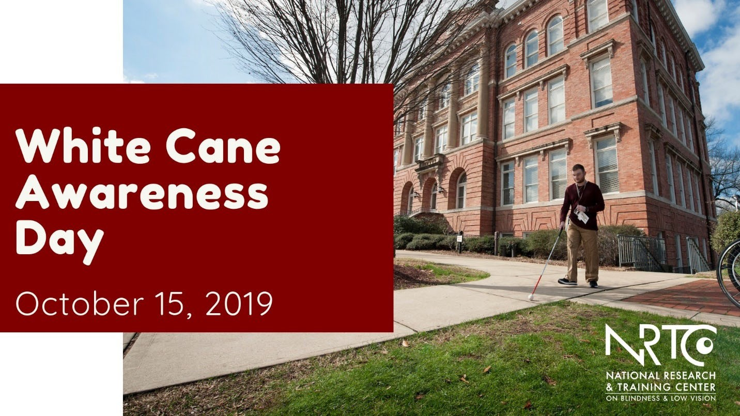

Event Promotion - Interviews
Once your event is planned with consideration of your budget, sponsors, and volunteers, the next step is publicity. Be sure to contact local newspapers and radio stations through a press release (example later in the guide). Be sure to post on your social media accounts, websites, and newsletters to notify invested stakeholders.
If your press release is successful, you may be asked to provide an interview. The key to a successful interview is preparation!

Before the interview
Before you engage in an interview, consider:
- Location - Will it be at your office, their station/office, or another location?
  - If in your home or office, be sure to find a place where you will not be interrupted, and that is quiet. Tell your family members or coworkers not to interrupt you.
  - If at another location, be sure to get there before your interview time!
- Timing - How long is the interview? Do you have time to elaborate and provide rich details and examples? Do you instead need to think succinct sound bites?
- Preparation - Create a cheat sheet with possible answers to common questions, such as:
  - What is White Cane Awareness Day?
  - What is a white cane?
  - What can you do if you see someone using a white cane?
  - What can you expect from this event?
  - Why should the listener/reader/viewer attend?
  - Where can the listener/reader/viewer get more information?
Practice these answers, but do not memorize them to allow your responses to still flow naturally.
- Regardless of a live or edited interview, the medium of the message matters for your preparation and presentation:
  - Radio means you can have notes in front of you. You'll want to speak to the interviewer and listeners more conversationally. Imagine you are talking to a friend about the event. Avoid filler words and pauses.
  - Broadcast/ TV interviews can feel a bit more daunting since you'll usually have a microphone and camera in front of you. You'll want to speak more formally and use positive body language to get your message across.
  - Print interviews provide grace for nervous body language and filler words. In this medium, your words are the only message.
- Audience - Who are the listeners, viewers, or readers? Tailor your message to match the audience.
- Support the interviewer - Send the interviewer your short bio and a summary of your event activities a couple of days before your scheduled interview. This

courteous act ensures they have accurate details about you and your event before the interview.
Tip: Most interviewers will provide you the opportunity to say something at the end. Consider creating a powerful, concise closing statement in preparation for a great answer!

During the interview
Be sure to have your cell phone on silent. You do not want to have any interruptions that may distract you, the interviewer, or the listener. Remember to avoid jargon and breathe. You have practiced and prepared for this interview. So, now, let your passion take the lead!
Tip: Bring water to drink with you!
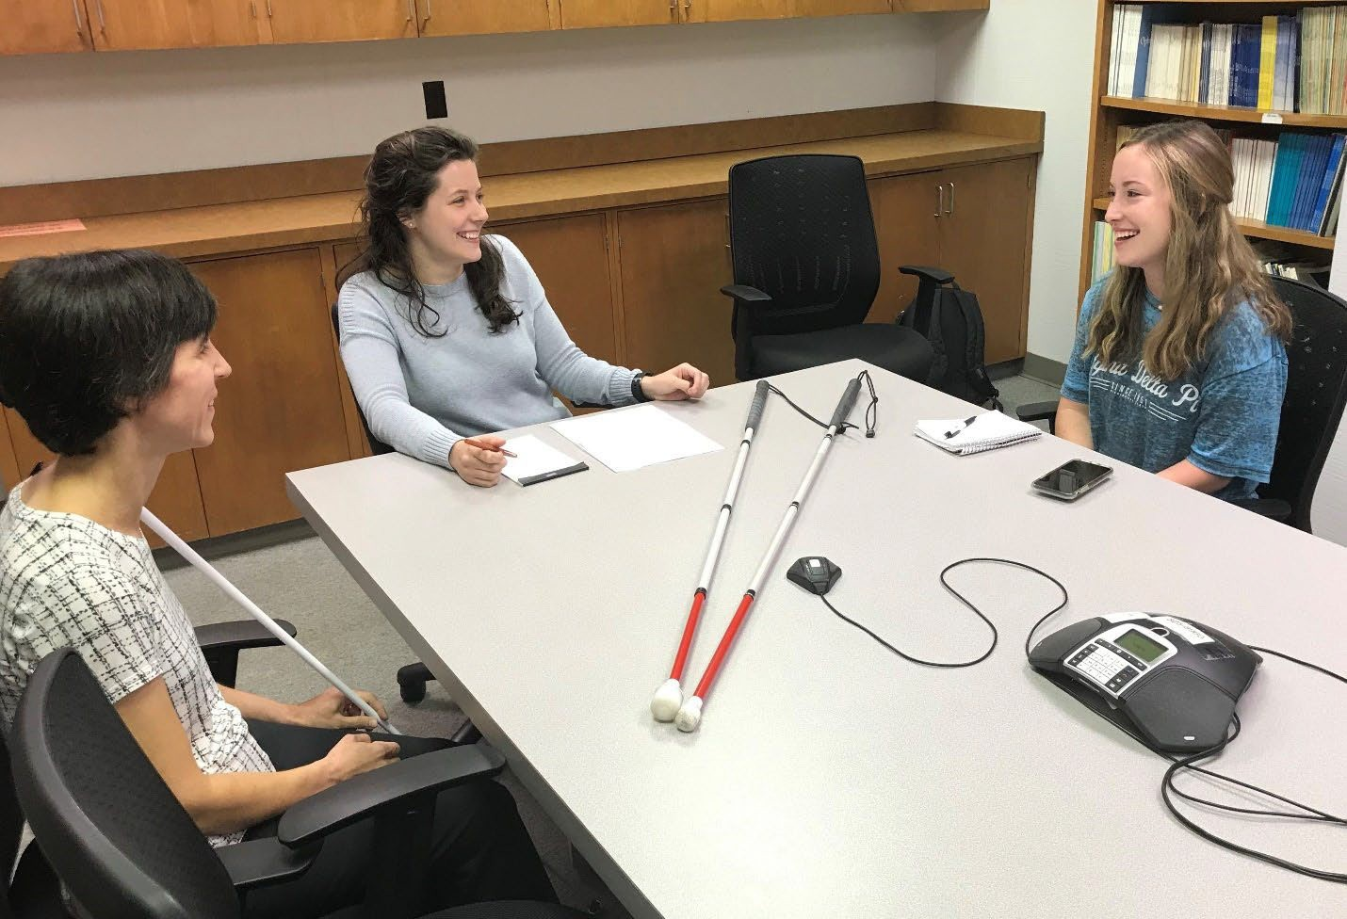

After the Interview
After the interview, consider writing a thank you note. The thank-you note could acknowledge their time - scheduling the interview, hosting the interview, and (possibly) editing the interview for their audiences.
Be sure to publicize and promote the interview through your own channels.

Event Promotions - Invitations
Remember to send personalized invitations that include the event's who, what, when, where, why, how, and contact person. Here is a list of organizations you may want to invite to your event:
- Local police department
- County Sheriffs office
- Local fire department
- Local schools
- Local city officials
- Local vocational rehabilitation agencies

- Local services groups (e.g., Lions Club chapter)

- Local AER Chapter
- State affiliate NFB group
- State affiliate group of American Council of the Blind (ACB)
- National Rehabilitation Association Regional Chapters
Tip: National Federation of the Blind may share information about your event on their Meet the Blind month page.

Sample invitation
Dear [Name],
Given that your [staff/group/other] may at times interact with a person with blindness, we would like to invite you to attend our White Cane Awareness Day celebration. The celebration of this tool perfectly aligns with our mission to enhance employment and independent living outcomes for individuals who are blind or have low vision through [research/training/education].
This year, we will host [proclamation signing/informational fair/other] on [date and time] at [location].
We will have lots of activities ... [information about activities].
This event might be especially beneficial for any of your [staff/group/other] who have not ever met a person who is blind or has low vision. We hope that this event will spread awareness and provide an educational opportunity for our community.
If you have any questions, please contact me at [information]

T-Shirts
Providing t-shirts to your staff allows them to be easily identified at the event for possible assistance. This is great if you have a large event where staff may get lost in a crowd.
Tip: Giving volunteers a t-shirt is a great way to thank them for their time. If you decide to do this, consider having a slightly modified t-shirt for staff versus volunteers to differentiate possible assistance and knowledge levels. Similarly, you could provide a button to differentiate.
Selling t-shirts is a great way to fund the White Cane Awareness Day activities. As previously mentioned, sponsor logos can be placed on at-shirt to obtain funds.
Additionally, you could sell t-shirts in advance and/or at the event for further financial support.
Shirts worn after the event will remind attendees of the event and provide recognition for the next year's event. Therefore, consider adding your logo or website to the design.
Here is an example of a White Cane Awareness Day t-shirt:
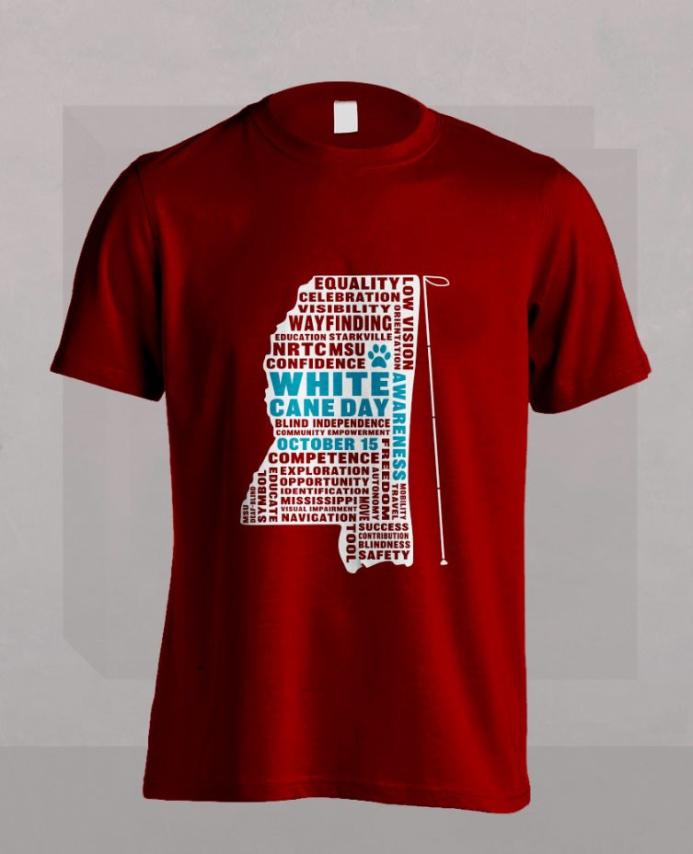

Sample Press Release
[Title of organization] [Phone number] Contact: [Name] [Contact Email] [Date]
MEDIA ADVISORY: [Name of city] Mayor to sign White Cane Awareness Day Proclamation

WHO: [City] Mayor, [Mayor's name], and representatives from [your organization] with the support of [any partners]

WHAT:

WHEN:

WHERE:
[City] Mayor, [Mayor's name] will affirm the significant role that persons with disabilities have in our local community by signing a White Cane Awareness Day proclamation. This day - October 15 - is set aside to recognize the white cane as a tool of independence

[date and time]

[address]

CONTACT: For more information, contact [contact name], [contact title], at [number] or [email].

