Never Lose Sight

Community Outreach for Low Vision or Blind
Veterans or Civilians

Come out and learn what’s available to you!

CTA Transportation Available
Call 896-8080 to Schedule

August 16th, 2021
6 PM to 8 PM
Margaret Sherry Library
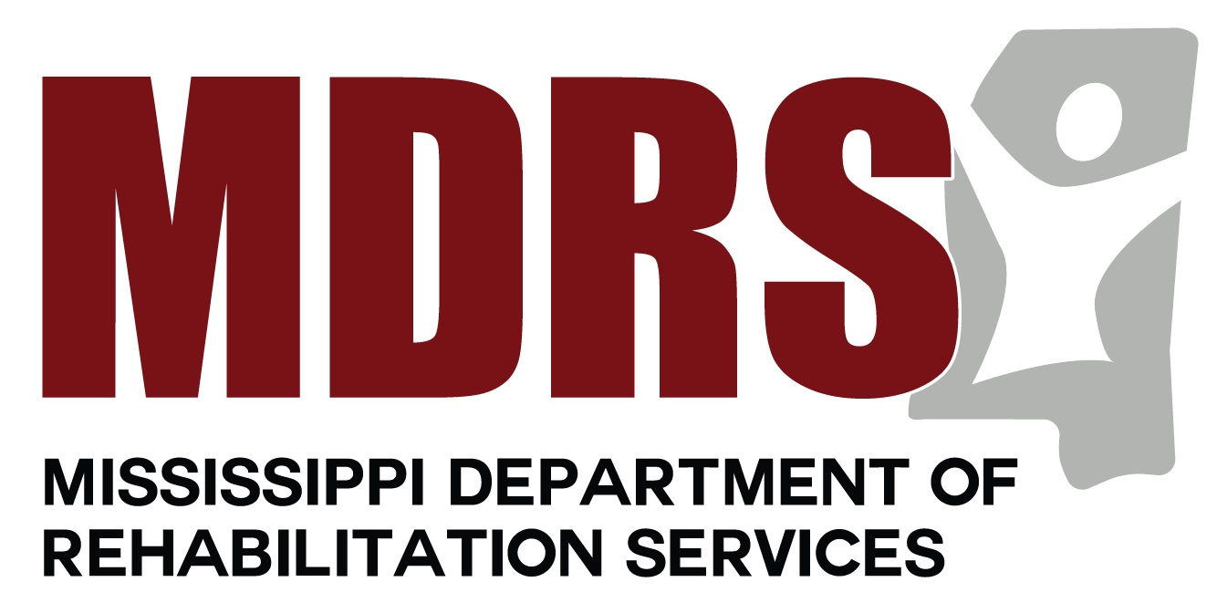
Popps Ferry Rd, Biloxi

