77th National Convention Registration Form
The Hyatt Regency Washington on Capitol Hill, Washington, DC
August 22-26, 2022
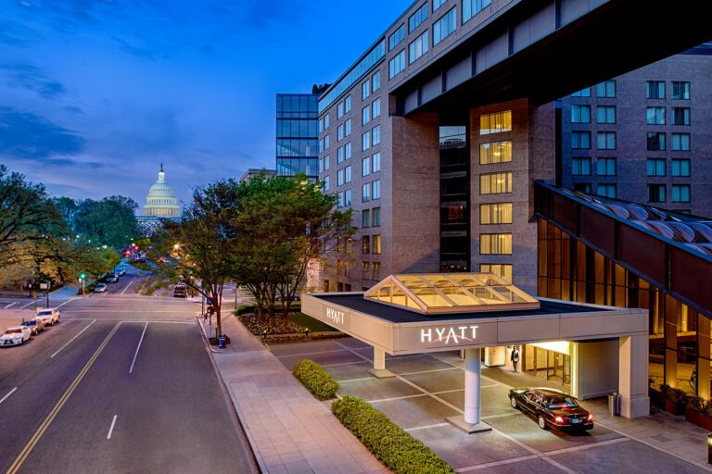
The BVA National Convention is the one time each year that blinded and visually impaired veterans meet directly with VA Blind Rehabilitation Services leadership and other rehabilitation professionals to learn about and discuss new products, services, and technologies.
The Hyatt Regency Washington on Capitol Hill is offering rooms for $145.00 per night (plus a 14.95% state and local tax). The Hyatt Regency Washington on Capitol Hill offers complimentary standard Wi-Fi in guest rooms as well as use of their indoor pool and fitness center.
The hotel is offering complimentary airport transportation ONLY from the Ronald Reagan Washington National Airport (DCA) BY RESERVATION. Their shuttle service is being worked out at this time. More information will be presented at a future date.
While on property, enjoy Starbucks in their gift shop; breakfast, lunch and dinner in Article One; or snacks and drinks from the Article One Lounge.
To reserve your room, please use the convention room booking link (CLICK HERE). You can also call (800) 233-1234 and use room block code “G-BVET” to make your room reservation. The room block rate is available from August 21st-27th, 2022.
For travel assistance we encourage you to contact Brenda K. McDaniel (Independent Travel Consultant) and daughter of a BVA member. Please contact Brenda (between the hours of 11:00am – 6:30pm EST) via email at brenda_mcdaniel@sbcglobal.net, or via telephone at (915) 204-0101.
Please complete the convention registration form. Should you require assistance completing this process contact BVA National HQ via email at bva@bva.org, or via telephone at (800) 669-7079 x 304.

2022 REGISTRATION FORM

FIRST NAME: ___________________________________ MIDDLE NAME: __________________________________
LAST NAME: ____________________________________

PRIMARY MAILING ADDRESS: _____________________________________________ APT: __________________
CITY: __________________________________________ STATE: _____________________ ZIP: ___________________
COUNTRY: ____________________________________

PRIMARY EMAIL: ____________________________________________________________________________________
PRIMARY PHONE NUMBER: ________________________________________________________________________

EMERGENCY CONTACT NAME: ____________________________________________________________________
EMERGENCY CONTACT PHONE NUMBER: ________________________________________________________

ARE YOU A BVA MEMBER: YES NO (Non-member fee is $210)

ARE YOU A MEMBER OF A REGIONAL GROUP: YES NO
REGIONAL GROUP NAME: __________________________________________________________________________
T-SHIRT SIZE: ____________________

WILL YOU BE BRINGING A GUEST? YES NO Guest fees are $125/person

GUEST NAME: ______________________________________ GUEST EMAIL: ________________________________

GUEST T-SHIRT SIZE: ___________________

WILL YOU BE BRINGING A SERVICE DOG? YES NAME OF SERVICE DOG:___________________

DO YOU OR YOUR GUEST HAVE ANY FOOD RESTRICTIONS/ALLERGIES/MEDICAL ISSUES?

IF YES, PLEASE LIST: _______________________________________________________________________________

WILL YOU REQUIRE A WHEELCHAIR? YES NO
WHICH OFFSITE EVENTS WOULD YOU BE INTERESTED IN?

EVENT | YES (Please check all that you would be interested in) | NO
Bowling
Bus Tours
Walking Tours
Kayaking
Scavenger Hunt

PLEASE LIST OTHER EVENTS YOU WOULD BE INTERESTED IN ATTENDING:
______________________________________________________________________
WILL YOU REQUIRE AN OFFSITE GUIDE? Yes No
PAYMENT INFORMATION: Registration fee is $125.00/person and $210 for non-members
My check made payable to Blinded Veterans Association is enclosed. Mail your check to Blinded Veterans Association, PO Box 90770 Washington, DC 20090: Contact BVA Convention Coordinator @ mbuonodagrossa@bva.org or call 202-371-8880 x 304 with any questions.
Charge my credit card: AMEX MasterCard VISA
Card Number: ______________________________________________
Exp. Date: ____________________________ CVV2 ________________
Amount Authorized: $__________________
Name on Card (print): ______________________________
Signature: _____________________
Billing Address: ________________________________________________________________

