September 12, 2023

Mr. Paul Mimms National President
Blinded Veterans Association 1726 M Street, NW Washington, DC 20036

Dear Mr. Mimms,

On behalf of the House Committee on Veterans' Affairs, I want to extend my congratulations on your election as the new National President of the Blinded Veterans Association. Your election is a testament to the confidence that your members have in your ability to lead and assist our nation's veterans and their families. I'm confident this marks the beginning of a promising chapter for the BVA.

Your unmatched dedication and many years of service to active-duty servicemembers and veterans exemplify great leadership and commitment to our nation as a whole.

I also want to thank you for your service to our nation's Navy and your continued advocacy on behalf of blinded veterans who have also answered the call. The positive impact you have had on our veterans has culminated in this excellent opportunity for you to lead the entire organization and leave a legacy that will improve the lives of current and future veterans alike.

This is no small task, but I know that because of your passion and responsibility, the BVA will prosper and strengthen its efforts to expand programs and push forward necessary legislation for our veterans in need.

Please accept my best wishes as you assume this new role. Your leadership is an inspiration to all of us, and I am looking forward to seeing the accomplishments and impact of the BVA.

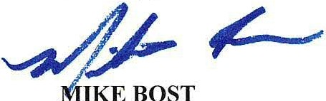
Sincerely,
Chairman

