BVA 79th National Convention Overview

1

2

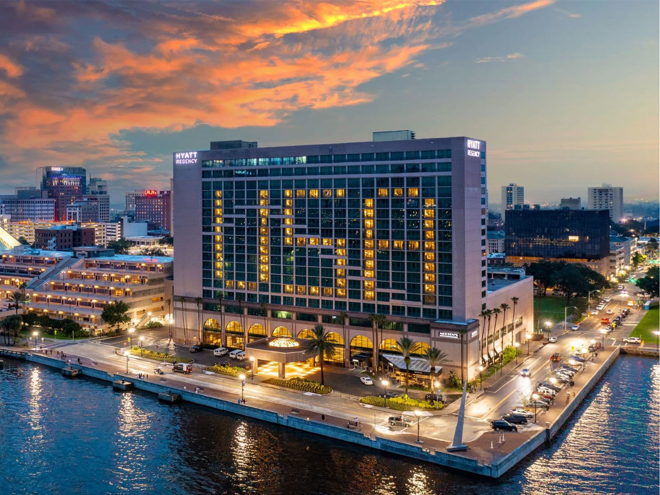Important Dates

- BVA/ACB National Convention:
  - July 5-12 (Friday – Friday)
- BVA Business Meetings:
  - July 7-10 (Sunday – Wednesday)
- ACB Offsite Tours:
  - July 5-12 (Every day except Thursday, July 11)
- BVA will NOT be conducting offsite tours. If you would like to sign up for tours, you must register and pay through ACB. Registration for tours opens in May.
- For any offsite tour questions, please contact Janet Dickelman, ACB Convention Chair, at (651) 428-5059 or via email janet.dickelman@gmail.com

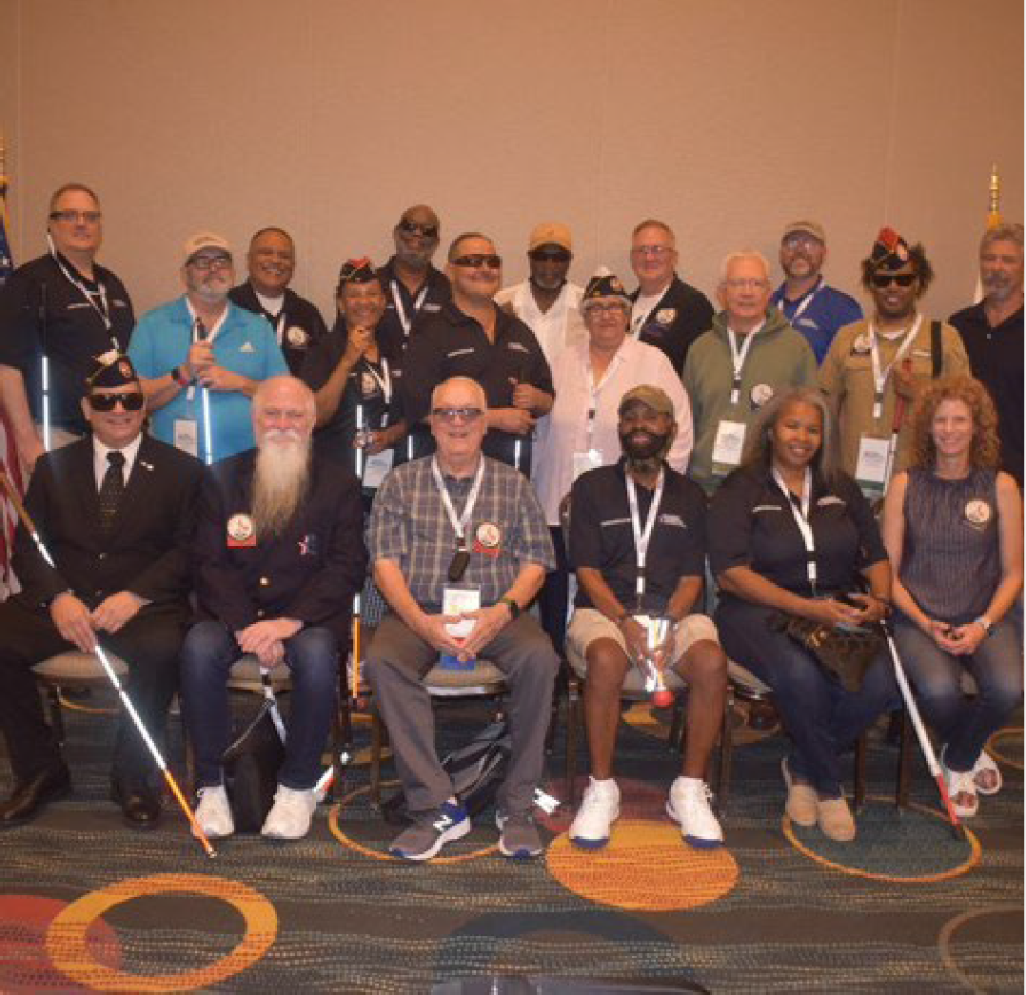https://BVA.org

Registration Information
- $150 per person for BVA members, BVAA members, guests, and non-members.
- BVA Registration will open at the end of February/early March. All members MUST register online at BVA.org.
- Registration includes:
  - Convention Bag
  - T-shirt
  - BVA Business Meetings
  - Father Carroll Luncheon
  - BVA Gala
- Due to manpower limitations, if you require special assistance of a caregiver, you will be required to make those arrangements and register them as a guest.
3

Hotel Information
https://BVA.org

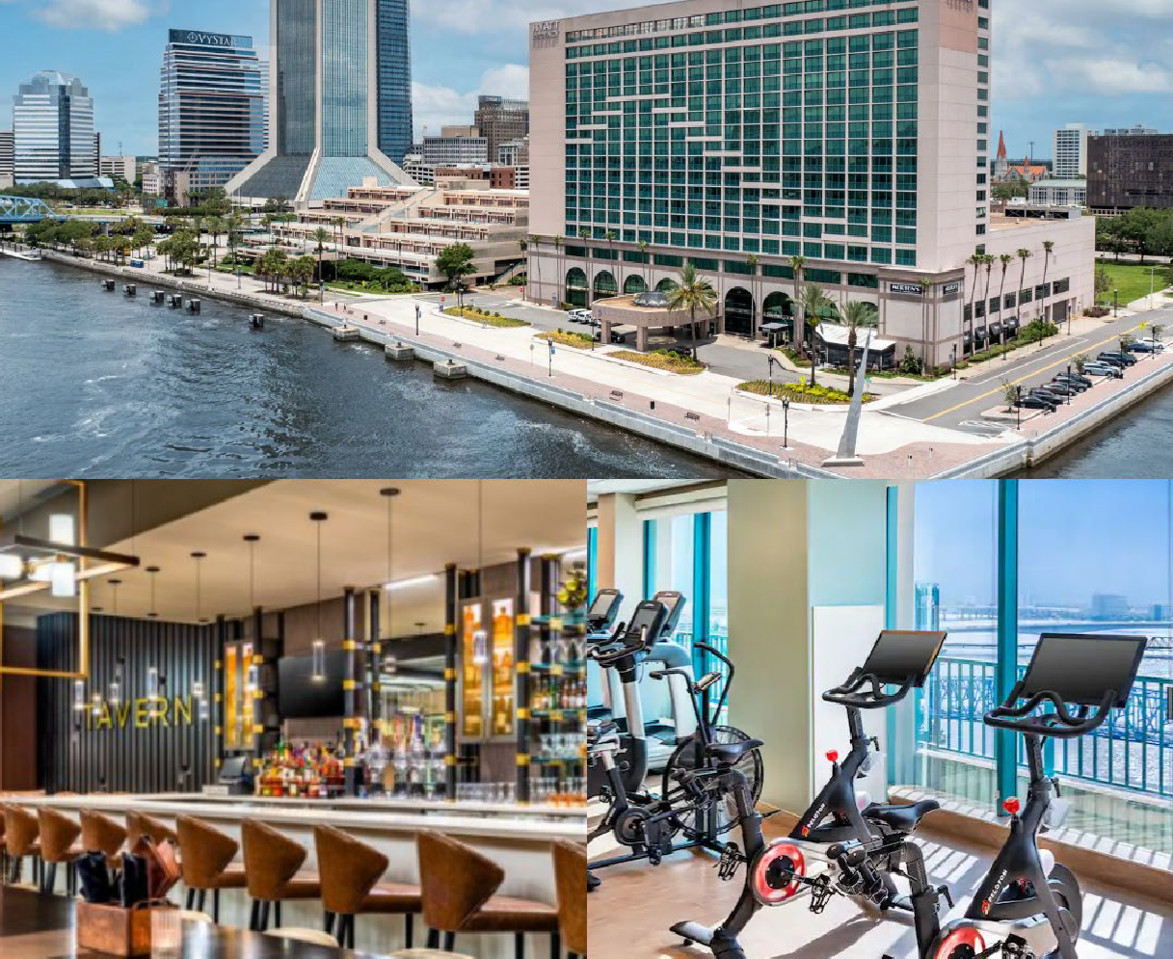
4

- Address:
  - The Hyatt Regency Riverfront Jacksonville 225 East Coastline Drive, Jacksonville, FL 32202
- Room Rates:
  - $99 per night plus tax
- Accommodations include:
  - Free Wi-Fi in guest rooms and social spaces
  - Refrigerators in each room
  - Heated outdoor pool
  - 24-hour fitness center
- To make reservations via:
  - Online: https://www.hyatt.com/en-US/group-booking/JAXRJ/G-ACOB
  - Phone: call (800) 233-1234 and use Code G-ACOB. To receive the group rate you must register by June 10, 2024
- Hotel Parking:
  - Self-parking at the hotel is $15 per day. This fee includes day, overnight, and in/out privileges. The garage is on Newnan Street.
- Dog Relief Area:
  - TBD

Hotel Dining Options
https://BVA.org

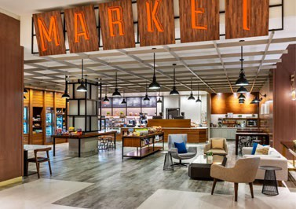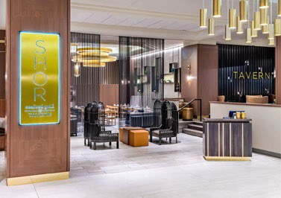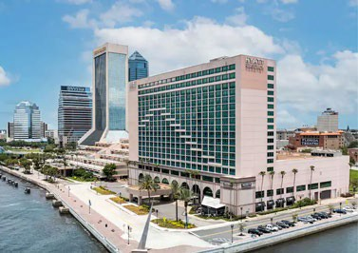Market: open 24/7 featuring fresh brewed Starbucks® coffee and specialty drinks, sandwiches, pastries, bottled beverages, and souvenirs.

SHOR Seafood Grill: Serving a variety of American and seafood dishes for breakfast, lunch and dinner.

TAVERN: Enjoy handcrafted beverages, light fare, and signature entrées in a modern bar setting.

Mortons The Steakhouse: Savor generous portions of USDA prime aged beef, as well as fresh fish, lobster and chicken entrees served with Morton's animated signature tableside menu presentation.
5

https://BVA.org
6

Transportation to the Hotel
Please note that a shuttle will not be provided. You will be required to arrange transportation to and from the airport. When you finalize your travel plans, please send your itinerary to Margarine Beaman at oleo501625@outlook.com who will be assisting with navigation to the best of her ability.

Transportation Options

Airplane
- The Jacksonville Airport (JAX) is 15 miles from the hotel.

Bus

- If you plan to travel by bus, the Greyhound station is 1.2 miles from the hotel and is located at 1111 W Forsyth St. Megabus also drops off at the Greyhound station.

Train
  - If you plan on taking the train, Amtrack’s station is 5.6 miles from the hotel and is located at 3570 Clifford Lane.

Local Transportation
  - Uber or Lyft will cost approximately $25 from the airport to the hotel. A taxi is about $10 more.
7

Renting accessibility devices and paratransit information

Paratransit Information
  - TBD

Renting a Wheelchair or Scooter
  - If you would like to rent a wheelchair or scooter you will need to reserve as soon as possible to make sure your request can be honored. Rental minimum is for one week (most economical) Friday, July 5- July 12 and includes delivery and pick-up from the hotel. You will need to pay for the rental with a credit card. Once you have reserved, please email janet.dickelman@gmail.com. Janet (ACB) will keep a list to ensure everyone receives their items. The wheelchair or scooter will be at the front desk under your name.

Where to rent:
    - Action Disability Resources, Inc
    - Contact: Jared
    - P: (904) 777-1979

Wheelchair Pricing
    - 16 or 18 inch = $100
    - 20 inch = $115
    - 22 inch = $125

Scooter Pricing
    - 3 or 4 wheeled = $125
8

BVA Schedule of Events

Sunday, July 7
- Time TBD BVA Registration
- 9:00am-5:00pm Exhibit Hall Opens
- 7:00pm-8:00pm BVA/ACB Joint Opening Ceremony

Monday, July 8
- Time TBD BVAA Meeting
- 9:00am-11:30am Opening Business Meeting
- 1:00pm-3:00pm BVA Bylaws and Resolutions
- 6:00pm-9:00pm BVA Gala Dinner

Tuesday, July 9
- Time TBD BVAA Meeting
- 7:30am-8:45am BVA Ambassador Breakfast
- 9:00am-11:30am BVA Membership Engagements
  - 9:00am-10:00am Q&A with the Board of Directors
  - 10:15am-11:30am Q&A with Team BVA
- 12:00pm-2:00pm Father Carroll Luncheon Awards Ceremony
- 3:00pm-6:00pm BVA Closing Business Meeting

Wednesday, July 10
- 8:00am-10:00am BVA Board of Directors Breakfast Meeting
9

Exhibit Hall Hours & Dates (Managed by ACB)

The Exhibit Hall will be managed by ACB this year. To order your Exhibit Hall Booth contact Michael Smitherman, Conference Exhibits Coordinator, by email at exhibitors@acb.org, or by phone at (601) 331-7740.

Guest Information

Exhibit Hall Hours
    - Sunday, July 7 from 9:00am-5:00pm
    - Monday, July 8 from 11:00am-5:00pm
    - Tuesday, July 9 from 11:00am-5:00pm
    - Wednesday, July 10 from 9:00am-1:00pm

Exhibitor Information
  - Exhibit Hall Set-up
    - Saturday, July 6 from 1:00pm-5:00pm
  - Exhibit Hall Open
    - Sunday, July 7 from 9:00am-5:00pm
  - Exhibit Hall Move-out
    - Wednesday, July 10 from 1:00pm-4:00pm
10

ACB Offsite Tours
Friday, July 5
- 8:30am-1:00pm Sea Serpent Airboat Tour
- 1:30pm-3:30pm City Bus Tour I – Jacksonville City Experience Driving Tour
- 3:45pm-6:30pm Food Tour – 3 Stops (Italian, Seafood, Dessert)
Saturday, July 6
- 8:00am-12:15pm iFly Indoor Skydiving
- 9:15am-11:15am City Bus Tour II – Jacksonville City Experience Driving Tour
- 9:00am-1:45pm Fort Caroline
- 1:00pm-3:00pm City Bus Tour III – Jacksonville City Experience Driving Tour
- 5:30pm-8:00pm Jacksonville Beach Pier
Sunday, July 7
- 6:30am-11:30am Autobahn Indoor Speedway
- 8:30am-10:30am City Bus Tour IV – Jacksonville City Experience Driving Tour
Monday, July 8
- Time TBD The Ritz Theatre and Museum of Southern History
- Time TBD Beach Party
11

Tuesday, July 9
- Time TBD Florida School for the Deaf and the Blind
Wednesday, July 10
- 12:15pm-3:00pm Sweet Pete’s Candy/Lunch
- 2:15pm-5:00pm Sweet Pete’s Candy/Lunch
- 1:00pm-3:15pm USS Orleck
Thursday, July 11
- None
Friday, July 12
- 6:15pm – 6:30pm Kennedy Space Center; $285 with lunch provided

https://BVA.org
12

Questions?
If you have questions regarding Convention, please contact your District Director. Contact information may be found at: National Board – Blinded Veterans Association (bva.org)

