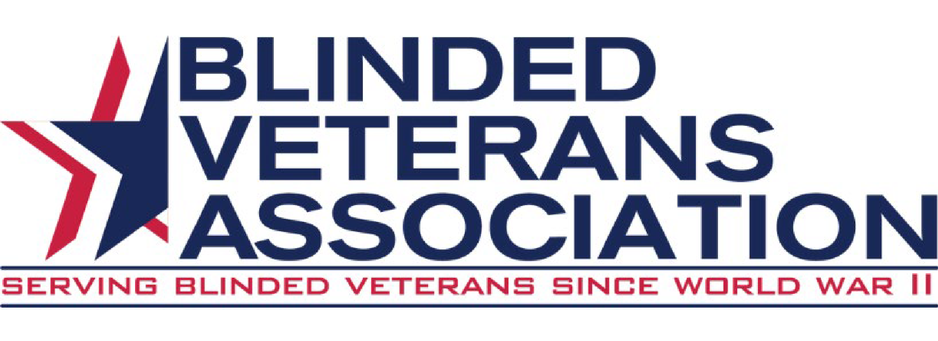

BVA 79th National Convention Overview

1

2

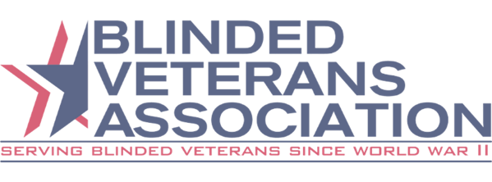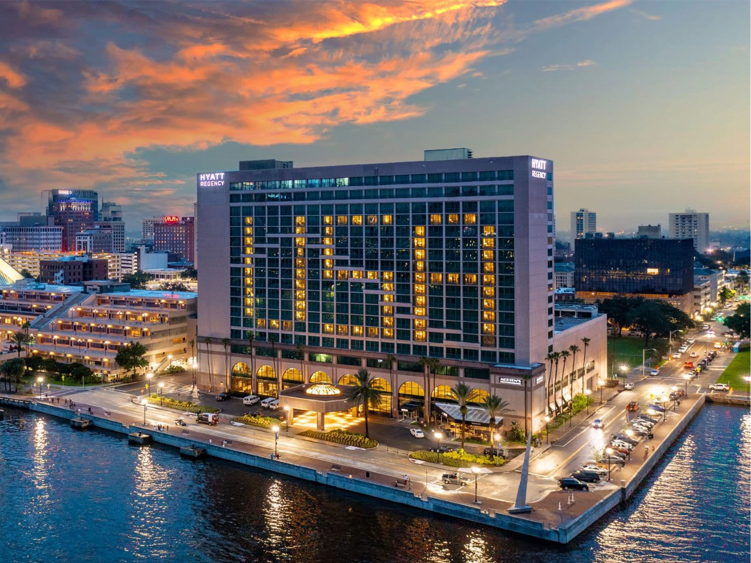Important Dates

- BVA/ACB National Convention:
  - July 5-12 (Friday – Friday)
- BVA Business Meetings:
  - July 7-10 (Sunday – Wednesday)
- ACB Offsite Tours:
  - July 5-12 (Every day except Thursday, July 11)
- BVA will NOT be conducting offsite tours. If you would like to sign up for tours, you must register and pay through ACB. Registration for tours opens in May.
- For any offsite tour questions, please contact Janet Dickelman, ACB Convention Chair, at (651) 428-5059 or via email at janet.dickelman@gmail.com

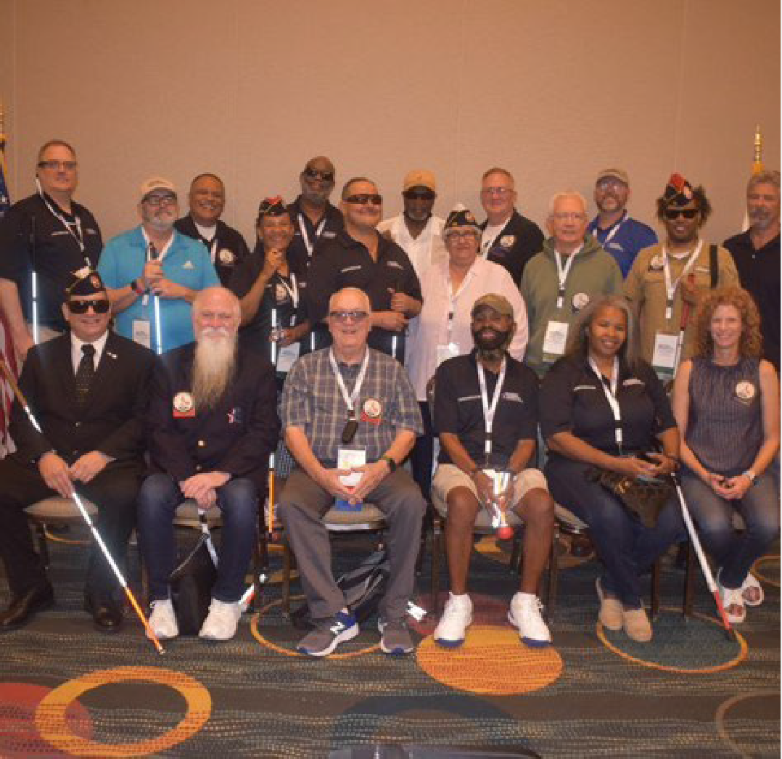https://BVA.org

Registration Information
- $150 per person for BVA members, BVAA members, guests, and non-members.
- BVA Registration will open at the end of February/early March. All members MUST register online at BVA.org.
- Registration includes:
  - Convention Bag
  - T-shirt
  - BVA Business Meetings
  - Father Carroll Luncheon
  - BVA Gala
- Due to manpower limitations, if you require special assistance of a caregiver, you will be required to make those arrangements and register them as a guest.
3

Hotel Information
https://BVA.org

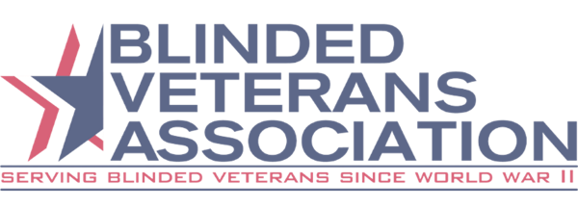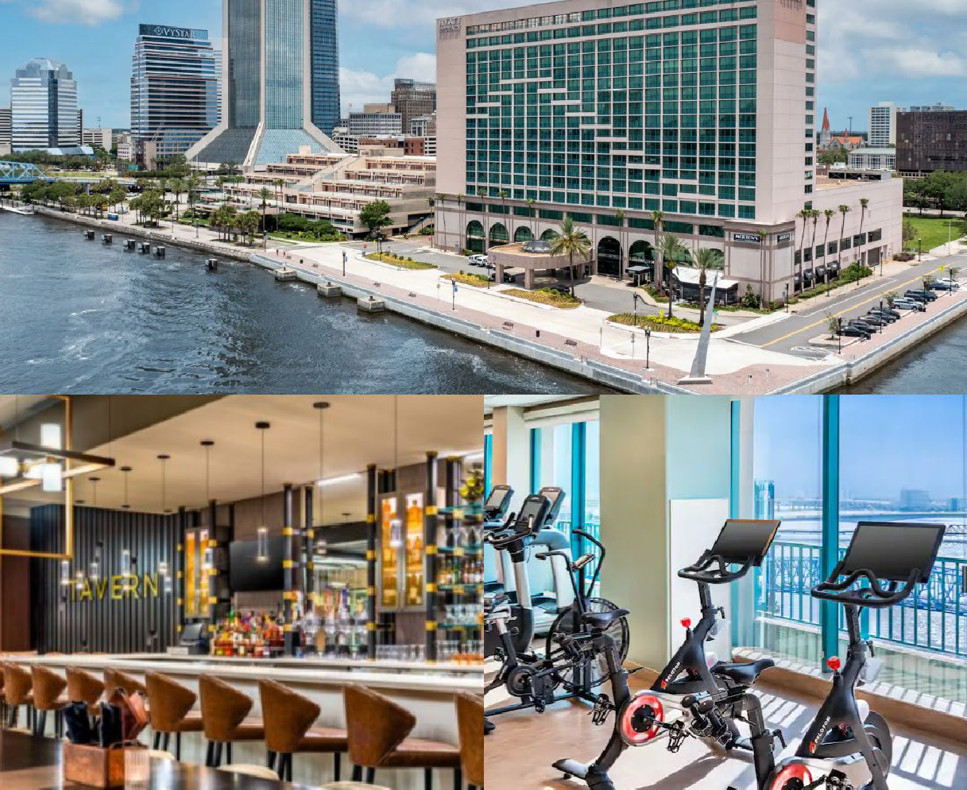

- Address:
  - The Hyatt Regency Riverfront Jacksonville 225 East Coastline Drive, Jacksonville, FL
- Room Rates:
  - $99 per night plus tax (Single or Double Occupancy),$124.00 (Triple Occupancy), $149.00 (Quadruple Occupancy)
  - The cost of a king room is $109.00 per night
  - Room tax is 14.64%
  - Upon check-in a charge of $40.00 per night for incidentals will be charged to your credit or debit card
- Accommodations include:
  - Free Wi-Fi in guest rooms and social spaces
  - Refrigerators in each room
  - Heated outdoor pool 24-hour fitness center
- To make reservations via:
  - Online: https://www.hyatt.com/en-US/group-booking/JAXRJ/G-ACOB
  - Phone: call (800) 233-1234 and use Code G-ACOB. To receive the group rate you must register prior to June 14, 2024
- Hotel Parking:
  - Self-parking at the hotel is $15 per day. This fee includes day, overnight, and in/out privileges. The garage is on Newnan Street.
4

Dog Relief Area
https://BVA.org

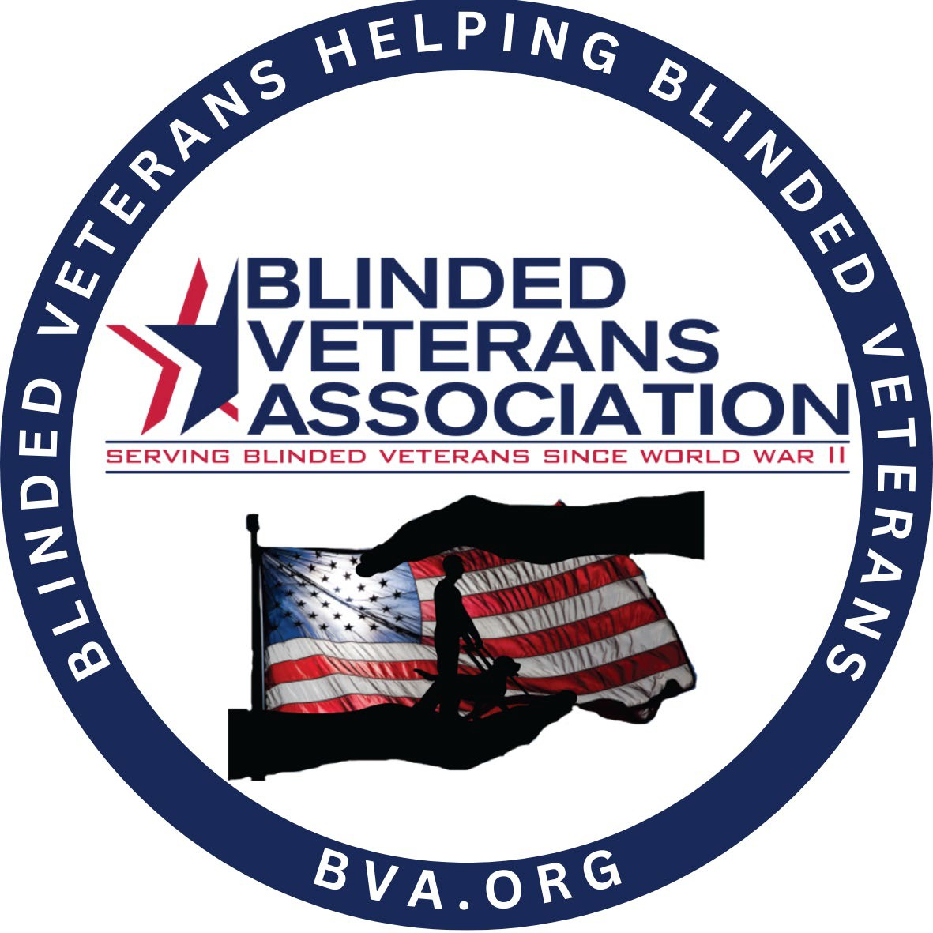

Dog Relief Area:
- Scoopmasters will provide and maintain our dog relief areas in Jacksonville.

- If you would like to preorder dog food to be delivered to your hotel room, call Tim Stone at (661) 714-0749 or order online at
http://scoopmasters.com/acb.

- The form asks for name, phone number, brand and type of food. Tim, from Scoopmasters will call to get the details within 24 hours and will accept payments at the hotel.

- Food must be ordered by June 20th to ensure delivery.
5

Hotel Dining Options
https://BVA.org

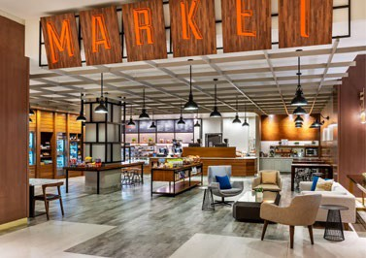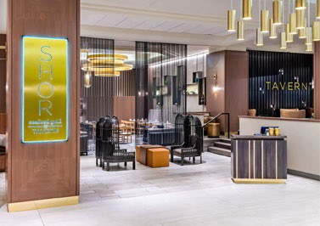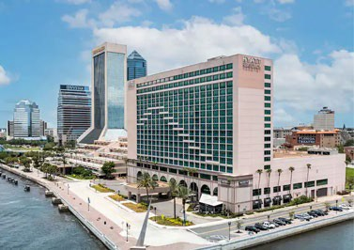Market: open 24/7 featuring fresh brewed Starbucks® coffee and specialty drinks, sandwiches, pastries, bottled beverages, and souvenirs.

SHOR Seafood Grill: Serving a variety of American and seafood dishes for breakfast, lunch and dinner.

TAVERN: Enjoy handcrafted beverages, light fare, and signature entrées in a modern bar setting.

Mortons The Steakhouse: Savor generous portions of USDA prime aged beef, as well as fresh fish, lobster and chicken entrees served with Morton's animated signature tableside menu presentation.
6

https://BVA.org
7

Transportation to the Hotel
Please note that a shuttle will not be provided. You will be required to arrange transportation to and from the airport. When you finalize your travel plans, please send your itinerary to Margarine Beaman at oleo501625@outlook.com who will be assisting with navigation to the best of her ability.

Transportation Options

Airplane
- The Jacksonville Airport (JAX) is 15 miles from the hotel.

Bus

- If you plan to travel by bus, the Greyhound station is 1.2 miles from the hotel and is located at 1111 W Forsyth St. Megabus also drops off at the Greyhound station.

Train
  - If you plan on taking the train, Amtrack’s station is 5.6 miles from the hotel and is located at 3570 Clifford Lane.

Local Transportation
  - Uber or Lyft will cost approximately $25 from the airport to the hotel. A taxi is about $10 more.
8

Paratransit/ADA Jacksonville Information
- Contact your local paratransit so they can email or fax your information/visitor request form. This information should be emailed to Latoya at lwalker@jtafla.com or fax to (904) 265-8919.
- This request should be processed in early June for the start of the National Convention on July 7, 2024.
- Call Latoya at the Florida Paratransit office in Jacksonville at (904) 265-8949 to check for approval and to receive your client number. You will need this information to reserve a ride.

Costs and Payment:
- Connexion
  - Cost is $3 each way.
  - Rides must be reserved in advance. They cannot be made for the same day. Reservations can be called in seven days per week from 8 AM to 5 PM at (904) 630-3100.

Connexion Plus
  - $6 each way for 15 miles or less.
  - $2 each additional mile.
  - Private same day door to door service. Available 2 hours after calling.
  - If using this service from the airport the cost would be around $20.
  - CREDIT CARD payments only when you make you make your reservation.

For more information, or to download the app visit the website:
https://www.jtafla.com/ride-jta/paratransit-services/
9

Renting a Wheelchair or Scooter
Renting a Wheelchair or Scooter
  - If you would like to rent a wheelchair or scooter you will need to reserve as soon as possible to make sure your request can be honored. Rental minimum is for one week (most economical) Friday, July 5- July 12 and includes delivery and pick-up from the hotel. You will need to pay for the rental with a credit card. Once you have reserved, please email janet.dickelman@gmail.com. Janet (ACB) will keep a list to ensure everyone receives their items. The wheelchair or scooter will be at the front desk under your name.

Where to rent:
    - Action Disability Resources, Inc
    - Contact: Jared
    - P: (904) 777-1979

Wheelchair Pricing
    - 16 or 18 inch = $100
    - 20 inch = $115
    - 22 inch = $125

Scooter Pricing
    - 3 or 4 wheeled = $125
10

Schedule of Events-*Subject to Change

Sunday, July 7
- 8:30am-5:00pm – BVA VSP Office
- 9:00am-5:00pm – Bow Wow Lounge Sponsored by Waymo
- 9:00am-4:30pm – BVA Registration Open
- 9:00am-5:00pm – Exhibit Hall Open
- 7:00pm-8:00pm – 79th National Convention Joint Opening Ceremony
- Time TBD – Hospitality Suite
Monday, July 8
- 8:30am-5:00pm – BVA VSP Office
- 9:00am-5:00pm – Bow Wow Lounge Sponsored by Waymo
- 9:00am-11:30am – BVA Opening Business Meeting
- 9:00am-11:30am – BVA Auxiliary Opening Business Meeting
- 1:00pm-3:00pm – Bylaws and Resolutions Meeting
- 1:00pm-3:00pm – BVA Auxiliary Committee Meetings
- 5:00pm-6:00pm – BVA Gala Happy Hour
- 6:00pm-9:00pm – BVA Gala Reception
- Time TBD – Hospitality Suite
Tuesday, July 9
- 7:30am-8:45am – BVA Ambassador Recognition Ceremony
Sponsored by OrCam Technologies
- 8:30am-5:00pm – BVA VSP Office
- 9:00am-5:00pm – Bow Wow Lounge Sponsored by Waymo
- 9:00am-10:00am – BVA Auxiliary New Business Meeting
- 9:00am-10:00am – BVA Board of Directors’ Membership Open Forum
- 10:15am-11:30am – Team BVA Outreach Teams Panel
- 12:00pm-2:00pm – Father Carroll Luncheon and Awards Ceremony
- 3:00pm-6:00pm – BVA Auxiliary Speaker: Barbara Webb,
Dole Caregiver Fellow, Elizabeth Dole Foundation, Caring for Military Families, and Tricky Tray Winners Announced
- 3:00pm-6:00pm – BVA Closing Business Meeting
- Time TBD – Hospitality Suite
Wednesday, July 10
- 8:00am-10:00am – BVA and BVA Auxiliary National Board of Directors Breakfast and Meeting
11

Exhibit Hall Hours & Dates (Managed by ACB)

The Exhibit Hall will be managed by ACB this year. To order your Exhibit Hall Booth contact Michael Smitherman, Conference Exhibits Coordinator, by email at exhibitors@acb.org, or by phone at (601) 331-7740.

Guest Information

Exhibit Hall Hours
      - Sunday, July 7 from 9:00am-5:00pm
      - Monday, July 8 from 11:00am-5:00pm
      - Tuesday, July 9 from 11:00am-5:00pm
      - Wednesday, July 10 from 9:00am-1:00pm

Exhibitor Information

Exhibit Hall Set-up
      - Saturday, July 6 from 1:00pm-5:00pm

Exhibit Hall Open
      - Sunday, July 7 from 9:00am-5:00pm

Exhibit Hall Move-out
      - Wednesday, July 10 from 1:00pm-4:00pm
12

ACB Offsite Tours

Friday, July 5
- 8:30am-1:00pm Sea Serpent Airboat Tour
- 1:30pm-3:30pm City Bus Tour I – Jacksonville City Experience Driving Tour
- 3:45pm-6:30pm Food Tour – 3 Stops (Italian, Seafood, Dessert)

Saturday, July 6
- 8:00am-12:15pm iFly Indoor Skydiving
- 9:15am-11:15am City Bus Tour II – Jacksonville City Experience Driving Tour
- 9:00am-1:45pm Fort Caroline
- 1:00pm-3:00pm City Bus Tour III – Jacksonville City Experience Driving Tour
- 5:30pm-8:00pm Jacksonville Beach Pier

Sunday, July 7
- 6:30am-11:30am Autobahn Indoor Speedway
- 8:30am-10:30am City Bus Tour IV – Jacksonville City Experience Driving Tour

Monday, July 8
- Time TBD The Ritz Theatre and Museum of Southern History
- Time TBD Beach Party
13

Tuesday, July 9
- Time TBD Florida School for the Deaf and the Blind

Wednesday, July 10
- 12:15pm-3:00pm Sweet Pete’s Candy/Lunch
- 2:15pm-5:00pm Sweet Pete’s Candy/Lunch
- 1:00pm-3:15pm USS Orleck

Thursday, July 11
- None

Friday, July 12
- 6:15pm – 6:30pm Kennedy Space Center; $285 with lunch provided

https://BVA.org
14

Questions?
Questions regarding Convention should be addressed to:
- Your District Director. Contact information may be found at National Board – Blinded Veterans Association (bva.org)
- You may also contact the Convention Committee. Contact information TBD.

