The VA Health and Benefits (VA HB) app is designed to give Veterans quick access to their most common VA tasks. Veterans said they wanted a single, fast, and intuitive place where they could complete common or recurring tasks across all of VA from anywhere and any device, including their mobile smartphones. This app does not replace VA.gov or MyHealtheVet--all of the app’s features are also available on the VA website.
The driving focus of the design and development is to:
- Provide access to the majority of the common tasks related to VA benefits.
- Enable access using no more than three clicks to get the information needed.
- Full accessibility for blind and low vision users.
- Provide the ability for user interaction with developers to improve the product.
VA has used four different credentialing services for verification purposes, and two are being retired. The My HealtheVet username and password is being retired on March 4, 2025. The DS Logon deadline is September 30, 2025.
The two remaining options are login.gov and ID.me. These credentialing services are used by VA, and by other governmental agencies and a host of companies to verify the status of users. In our case, veterans. You may already have an account set up to verify qualifications such as doctors, nurses, teachers, first responders and the like. Multiple qualifiers may be uploaded to an account, however in either case, only one account per person is allowed.
Regardless of whether you have one of these or not, please take the following steps:

- Go to the app store and download the free “VA Health and Benefits” app, which will have the VA logo.

- Once downloaded, you will be offered to use either login.gov or ID Me to access the app. Select which one you prefer.
- If you do not already have the apps, choose one.
- You will be prompted to either sign in or create an account. Click the create account button and it will bring you to the site chosen and start the setup procedures.
Please Note:
- Both will require a password of 8 characters or more with special characters.
- Both will require two factor authentication where you will receive a code via
e-mail.
- After this step you will have the option to use text messaging.
- You may also choose to use a pin which will be supplied. The app will tell you to write it down and save to a secure place.
- If you use a password manager such as keychain, you can add this to the notes. If you do not use a password manager, make sure you write the information down and secure it as you will have to refer back to it.
Once you have either a login.gov or ID Me account, you will have to create your VA HB account. This will require you to have either a state issued driver’s license or id card. No other form of identification will be accepted. These must be “real id” certified. You will be required to submit your information, take a photograph of the front and back of your id, and submit your social security number. Once completed and accepted, you will not have to repeat these steps again. Your VA HB account will automatically start downloading information to the app. Although fast, it may take a little while.
Once the app is set up and the download complete, you can start using it. There should be four buttons at the bottom described below. In these descriptions the word “back” is used to refer to the button in the top left corner that will bring you back to the previous page, if any. It will be read aloud with the description of that page instead of the word “back”.
- Home button-This has a synopsis of your basic information and upcoming appointments, disability rating, notifications, monthly compensation payments, how to contact the app developers, find VA locations, and stay abreast of the promise to address comprehensive toxics (PACT Act).
- Health button- This will allow you to view your upcoming appointments, securely message your Primary Care Manager, VIST, Pharmacy, and a whole host of other VA contacts. You can access your prescriptions and refills, and your immunizations.
- Benefits button- Here you will find all claims information for both open and closed claims, VA letters and documents, those received by mail, tax letters, proof of service, etc. In addition, your disability ratings including combined and individual, percentage, and date awarded.
- Payments button-This will have your payment history and allow you to update your direct deposit information.
- The “back” button- Although these directions call them the “back” button, they will read the previous page identifier and the word “link”. Like any other app, the location is in the top left corner and the first focus box (if using voice over). If you are at the beginning page of a tab, the first thing read aloud will be to “talk to the veterans crisis line now”.
On the home tab, in the upper right corner is the profile button. Select this to review or edit your proof of veteran status, your personal information, your contact information your military information and the app settings.
If your id card or driver’s license does not meet the photo requirements, you will have 5 chances to retake them. If your id is scratched, out of focus, or has other issues, the app will tell you to retake the photo. If after 3 attempts and it not accepting your photos, your best bet is to go to your post office and have your id verified by them. They will get a code and should assist you in completing the set-up.
The following directions are copied from the two services web sites and instruct how to set up an account. Remember, you can only have one account in your name for each service so you may need assistance in setting up the criteria. Do not get frustrated and be sure to write down any passwords, pins, codes, etc. Once set up you will be able to go into the specific app and change your password if desired.
Follow these steps to create your Login.gov account.
- Enter your email address at https://secure.login.gov/sign_up/enter_email to begin.
Choose an email address that you’ll always be able to access. Once your account is created, you can add an additional email address, such as a work email or alternate personal address, to access your account.
- Click the “submit” button.
- Check your email for a message from login.gov.
- Click the “confirm your email address” button in the message. This will take you back to the login.gov website.
- Create your login.gov password.
  - To help prevent identity theft, consider strengthening your password by using:
    - Unique phrases that only you recognize
    - Multiple words with spaces to get to 12 characters
    - Numbers and special characters
  - Your password must have 12 or more characters and avoid combinations such as:
    - Common phrases or repeated characters, like abc or 111
    - Parts of your email address or personal dates, like your birthday
    - The same password, or parts of it, that you use for other accounts, such as your bank account or email
- Set up a second layer of security.
As an added layer of protection, login.gov requires you set up an authentication method to keep your account secure. This is referred to as multi-factor authentication (mfa).We encourage you to have more than one authentication method on your account. You can choose from several authentication options.
More secure:
  - Security key
  - Face or touch unlock
  - Authentication application
  - Piv or cac card for federal government employees or military
Less secure:
  - Text message
  - Phone call
  - Backup codes
learn more about each authentication option to choose the one that is right for you.
- Success! Once you have authenticated, you have created your login.gov account. You will be taken to your login.gov account page or the government agency you are trying to access. You can add additional authentication methods, email addresses or update your information on the login.gov account page.
Follow these steps to create your ID Me account.

Before you begin
- Already have an account? Do not create another account. Instead, sign in to your existing account. If you can’t sign in, visit I can’t sign in to my account.
- Have a duplicate account? Visit duplicate account.

Eligibility
Anyone 18 years of age or older can create an id.me account.

Create an id.me account
To create your id.me account:
- Start at the website or organization where you need to use id.me. If you’re not sure where to begin, contact the organization directly.
- Select the id.me button.
- Select create an id.me account.
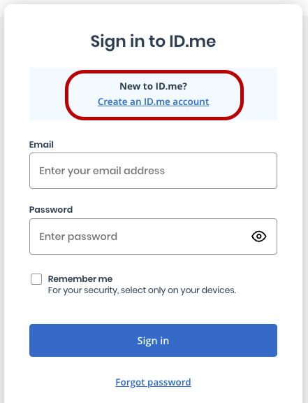

- Enter your personal email address, making sure it’s spelled correctly, without any typos.
- Enter a strong password, then select create account.
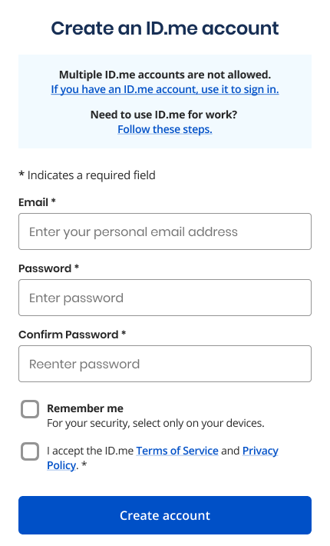
- Check your email inbox to confirm your email address.
- Set up multi-factor authentication (mfa), if prompted.
After creating your account, follow the prompts to verify your identity.

Troubleshoot creating an account:

I made a typo in my email address
If you accidentally misspelled your email address in the email field, you won’t be able to finish creating your account. Start the account creation process over and carefully enter the correct email address.

It says my email is registered with another id.me account
If your email address is already being used, visit duplicate email errors for next steps.

I need to use my id.me account for work
To learn how to use your id.me account for work, visit setting up your id.me account for work.

I created an account from the id.me website
If you created your account from id.me, go to the website where you need to use id.me. Select the id.me button, sign in to your account, then follow the prompts to verify your identity.

